MY SAFETY KIT
This resource is designed to support the reflections of people who are, or may be, experiencing domestic and family violence.
Page break
E mihi: Toitū te whenua, toitū moana, toitū te manu o te tāngata o te ao nui ki te ao wairua- tēnā koutou katoa.
Hāpaitia te ara tika, pūmai ai te rangatiratanga mō ngā uri whakaheke.
Respectful acknowledgment binds together land, sea, and people of past, present, and future. Foster the pathway of knowledge to strength, independence, and growth for future generations.
Foreword:
Ānei te mihi aroha ki a tangata whenua he tāngata tuatahi a Aotearoa, he rangatiratanga me te kanorau o ngā whānau me hapu iwi kātoa.
Response-Based Practice Aotearoa (RBPA) acknowledge tangata whenua as the first peoples of Aotearoa, and recognize richness and diversity within whānau, hapu and iwi.

Insight Exchange & RBPAotearoa uphold Tino Rangatiratanga in partnership with Māori – the generations who have gone before, and the generations yet to come. We extend this respect to all Indigenous peoples. We acknowledge Sovereignty was never ceded
SUPPORTS
Please note My Safety Kit is a resource not a service response. A range of supports and resources are listed in this resource from Page 32.
My Safety Kit is for all people. Insight Exchange respects the diversity of all sexualities and gender identities including but not limited to; Lesbian, Gay, Bisexual, Transgender, Intersex, Queer and A-Sexual + identities as well as Heterosexual and Cisgender identities.
Page break

One thing, or a whole lot of things, might not be right for me in my relationship.
I might be feeling uneasy, worried, unsafe, exhausted, fearful or unsure about what’s going on and what might happen next.
I might want to talk with someone about what’s going on. I might want to talk through my thinking and the I have been working through privately.
My Safety Kit is designed to support me (at my pace), with information and reflection questions about how I see things and what I might be thinking about, when looking ahead.
My Safety Kit is designed to support:

• existing safety awareness
• self-assessment of safety
• existing safety with possibly some new/extra ideas.

All relationships need to be safe. Including friendship, whānau, work relationships and intimate partners.
My Safety Kit is designed to support me to reflect on these questions:
• What did I hope for and what is going on in this relationship?
• What kinds of things am I having to do to stay safe and well?
• In what ways has my life changed since being in this relationship? How constricted has my life become?
• Why is this happening? Is it me?
• What decisions are important to me about my safety and wellbeing?
• What is available to me and who can support me?
• What is domestic and whānau violence?
Page break
WHAT DID I HOPE FOR AND WHAT IS GOING ON IN THIS RELATIONSHIP?
Page break
HONESTY FREEDOM OF EXPRESSION IS POSSIBLE WHERE THERE IS SAFETY.
I am wondering about some things…
Are my rights and boundaries respected?
Are we sharing the work in the relationship?
Are we both included in making decisions?
Am I able to safely express my thoughts and feelings?
Is there safety for everyone.
Can I safely talk about what I am and am not comfortable with?
Can I be open and honest about my intentions, feelings or desires?
Do we each take responsibility for our own actions?
Can I trust they will respect me and be honest and supportive?
Do I have the support and encouragement to achieve my goals and dreams, and personal growth?
THERE IS NO PLACE IN A HEALTHY RELATIONSHIP FOR CONTROLLING, ABUSIVE AND VIOLENT BEHAVIOUR.

Page break

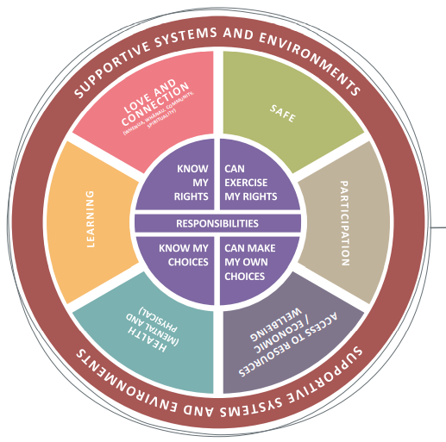
My wellbeing
“My wellbeing - and that of my children - matters to me and this includes my safety.
Being ‘safe’ is more than being physically safe – it includes all aspects of wellbeing.
Each area of wellbeing will also change over time as my needs, priorities and circumstances change.
Violence can undermine my wellbeing across many areas of life.”
Page break
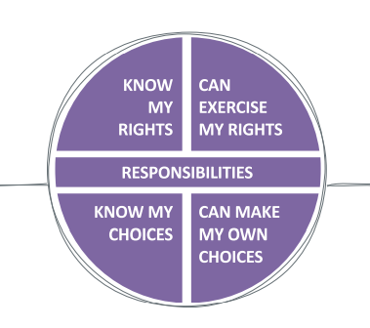
“The person using abuse and violence violates my rights and restricts my choices, and limits my capacity to act and put into action my own decisions.”
“I have the right to:
• live in peace and security, free from violence and abuse
• seek support
• be given information about things that concern me
• be asked for my consent and for my information and experiences to be managed with confidentiality
• be treated respectfully and with dignity
• make my own choices and decisions
I may have to prioritise safety over my right to autonomy.
When I am more aware of my rights and options, I am more able to make informed choices.
My choices are not only informed by my rights but also by my responsibilities (which may be linked to my civil, cultural, whānau, spiritual values).”
Page break
IN WHAT WAYS HAS MY LIFE CHANGED SINCE BEING IN THIS RELATIONSHIP?
WHAT KINDS OF THINGS AM I HAVING TO DO TO STAY SAFE AND WELL?
Page break
I am already active in resisting the violence and abuse, building safety for myself and others, and managing risk.
I am constantly...
Building my safety awareness through information and experience.
Implementing ways to keep myself and the people I care about safe.
Self-assessing my safety and watching for changes in risk, and forecasting risk.
Page break
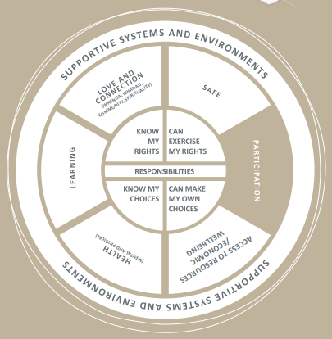
“My opportunities to participate, have a voice and be involved in the community and in my whānau, may be obstructed.”

Page break
What kinds of things am I having to do to engage safely and participate in community and whānau? Including my children’s participation?
What kinds of things am I having to avoid doing to stay safe in relation to my participation in community, and in my whānau?
Who knows about my circumstances, and supports my responses?
How are things changing? Is it safe to talk to someone? What could be different?

Page break
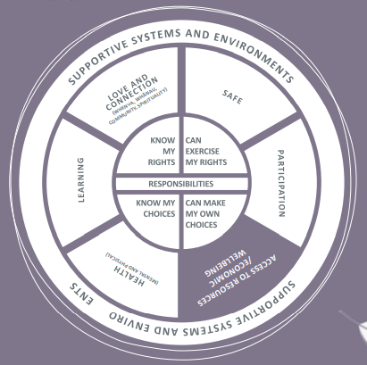
“The person abusing me tries to suppress my resistance by limiting my access to material basics, such as food, housing, clothing, and money, as well as assets and economic opportunities including study or employment.
If they can undermine my material and economic wellbeing, they will be more able to use violence.”

Page break

What kinds of things am I having to do to ensure I have access to material basics and support for my economic wellbeing?
What kinds of things am I having to do to provide for my children’s and help them stay safe and well?
Who supports me in taking the steps I may want to take?

How are things changing? Is it safe to talk to someone? What could be different?

Page break
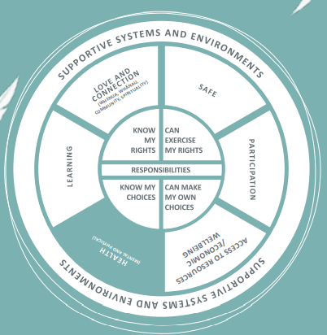
“My body and mind suffer from the violence and coercion. I can become physically unwell, fearful, desperate, lonely, sad, and angry.
My despair is one form of resistance to the violence, I may be seen as ‘clinically depressed’ or as having another disorder. My feelings are ethical emotional responses to violence.”

Page break

What kinds of things am I having to do about my physical and mental health to stay safe and well?

What kinds of things am I having to do about my children’s physical and mental health for them to stay safe and well?

Who understands I am not “ill” but responding to violence?

How are things changing? Is it safe to talk to someone? What could be different?

Page break

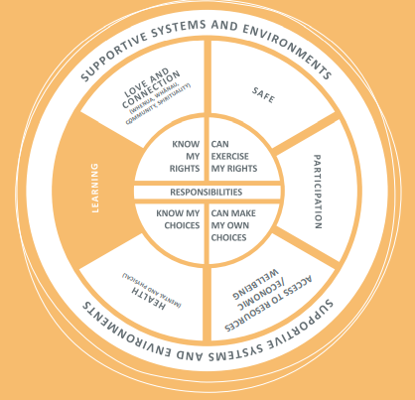
“Because I am forced to deal constantly with violence and abuse, and possibly with negative responses from others, I experience fatigue and isolation.
Sometimes I cannot help but ignore or avoid activities that could help me learn and develop as a person because of competing priorities related to safety.”

Page break

What kinds of things am I having to do, or not do to support my learning?
What kinds of things am I having to do about my children’s learning and growth for them to stay safe and well?
What kinds of things am I forced to do, to deal with negative responses from others?

How are things changing? Is it safe to talk to someone? What could be different?

Page break

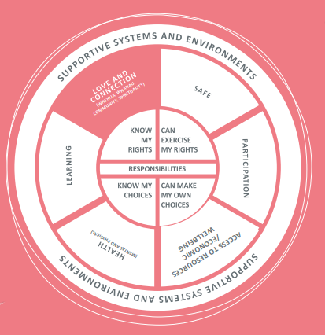
“The person using violence and abuse may isolate me from those I love and manipulate others against me, and undermine my relationships including my parenting. They may threaten or abuse my children, friends or whānau, pets, property, and things that are important to me as a means to control me. They may try to use my beliefs and spirituality to control and isolate me.”

Page break

What kinds of things am I having to do about my relationships and connections to stay safe and well?

What kinds of things am I having to do about my children’s relationships and connections for them to stay safe and well?

How am I remaining connected to others and to what I know is right? Even if only in the privacy of my heart and mind.

How are things changing? Is it safe to talk to someone? What could be different?

Page break
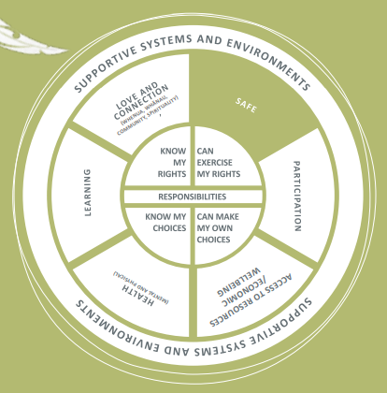

“I don’t like what is going on. I am resisting and responding to the abuse, trying to manage it. I didn’t attract it, I don’t accept it, but I can’t stop it.”

My safety is compromised, and I may be in danger of physical harm or being injured or killed.”

Page break

What kinds of things am I having to do to stay safe?
What kinds of things am I having to do to support my children’s safety?
What responses from others make me less safe or more safe?

How are things changing? Is it safe to talk to someone? What could be different?

Page break

“It is my right to be informed so that I can make informed choices and decisions about experiences and opportunities that relate to me and my children.”

You know your experience best; what it has been, how things are and what might happen next or if you change things. Talking about your experience can help to reveal the kind of danger you might be in, and the injustice you are experiencing.

When you share details about how you have been resisting and responding to the abuse and violence this can help to reveal how deliberate the abuse and violence is and how it is costing you and your children.

Page break

WHY IS THIS HAPPENING?

IS IT ME?

Page break

“I have been thinking about what is happening in my life and what it all means.”

It’s your life and you are closest to what is going on. You are experienced in anticipating the ways that the person abusing you uses against you and uses against the people you care about.

You can see how the person abusing you adjusts their strategies to suppress your resistance and responses to their abuse.

Their actions to abuse you may be similar to what others experience but are also completely unique and specific to you and the people you love

“I have been wondering if the person abusing me is in control of what they are doing.”
With rare exceptions, violence is deliberate. It requires intentionality, effort, and choice to be violent and abusive. The person might say they don’t want or mean to hurt or harm you, yet they do.
When they make excuses for how they abuse you, that tells you that they know it is wrong. That’s why they hide it from others or hide their behaviour behind excuses.
Page break
“I have been wondering if the violence and abuse is my fault.”
You are not experiencing violence because of a personality type or characteristic you have. You don’t ‘attract’ abuse. You might not be able to stop the violence and abuse but that doesn’t mean you ‘let it happen’.

“I have been thinking about whether I could have done more, or could be doing more, to make it stop.”
The responsibility to stop the violence rests with the person being abusive - even if the community and social media around you seem to suggest it is up to the victim of abuse to reduce, stop or escape the violence.
Everyone experiencing violence, resists and responds to the violence in their own ways. You might respond in ways that you hide from view and opinion in case you experience more judgement, danger or harm.
What you do may not always make sense or seem logical to people around you, but you are doing all you can with what you can, to create safety, avoid humiliation and more loss.

Page break

WHAT DECISIONS ARE IMPORTANT TO ME ABOUT MY SAFETY AND WELL BEING?

Page break
I know that being safe is no simple or single decision, or task.
I might have a decision to make, or I might want to keep thinking about my experiences and what my best options are.
I can use the decision-making tool (over page) on my own or with someone I feel safe to talk things through with.
Using the decision-making tool might be useful for:
• thinking through my hopes and worries, with or without someone else listening
• pausing to write down my thoughts so I can see a fuller picture when I am facing complex decisions
• collecting more ideas and strategies to safely make the steps I am hoping to make.
Decision Making Tool
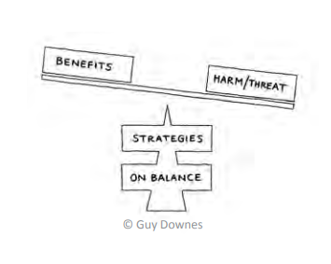
View the decision-making tool animation (3.5mins) www.insightexchange.net/my-safety-kit

Page break

I have my own sense of what is important right now and in the long term.

I have an idea about what I want to do next.

Benefits: What are the benefits of taking this step? If I do this what will be the benefits for me (and my children)
Harm/Threat: What are the potential harms or threats in this step and would that be to my safety and wellbeing (or my children’s)
Strategies: For this particular decision, in what ways could I reduce the potential harm or threat? What are the strategies I am already using or could start using if I make this step?
Balance: On balance, do I need to decide now? Who could support me with these?

Page break

Whether I am making a decision now, later or ever, it might be useful to document my experiences of actual and possible threat or harm, and or changes to my safety and wellbeing as a result of abuse, violence or injury.
This might be useful to me later on when I am:
• making a decision
• needing to provide a record of evidence.
I can use one or more of the apps that are designed to more safely and securely store my records. These may help me be more confident that they won’t be ‘seen’ by others or used against me.

One example is Arc: Arc is an app (or web platform) that supports you to safely collect evidence of family violence. It enables you to note events that make you feel threatened, scared, or unsafe in your relationship. Search for Arc in the Apple or Google Play app stores or visit: www.arc-app.org.au

Page break

There might be some things I can do in the meantime to build on my safety while I think about my options.

I can use one or more of the following links (and many more) to be aware of ideas and ways to build on my safety.

Being social
• Blogging
• Social Networking
• Online dating
•Online gaming
www.esafety.gov.au/women/being-social

Lifestyle
• Know your device
• Using your device
• Shopping and banking
www.esafety.gov.au/women/lifestyle

Taking control
• Online abuse
• Cyberstalking
• eSafety Planning
• Keeping your children safe online
www.esafety.gov.au/women/take-control Quick exit: The taking control webpage has a quick exit button
Women’s Information and Referral Exchange (WIRE) provides information on browsing anonymously www.org.au/browse-anonymously

Page break

WHAT IS AVAILABLE TO ME AND WHO CAN SUPPORT ME?

Page break

Responses from others are significant and play a part in my safety.

When someone is controlling and abusing me my situation is complex. No matter how much I try, no matter what ways I resist and respond, the abuser overcomes my resistance. Just because I cannot stop the abuse doesn’t mean I let it happen.
I might want to talk to someone about what is going on or to keep thinking about things first. I might want to think about who I want to talk to, and what I will say.
If or when I do reach out to someone (a person or a service), I don’t have to make any decisions, or all my decisions at once. And no-one should be expecting me to.
I might want to talk with someone about my experience and all the things I am doing already to stay safe. I might want to talk about where I might need support from others.
I might want to talk to someone on the phone, or to talk with someone in person.

About this directory
The list is not intended to be exhaustive. It includes frequently- accessed services that may be a useful starting point for you to explore.
Safe/Quick Exit buttons: Allow you to exit quickly. Browse history is not cleared

Page break

DEFINITION
Domestic and whānau violence includes any behaviour, in an intimate or whānau relationship, which is violent, threatening, coercive or controlling, causing a person to live in fear and to be made to do things against their will.
Domestic and whānau violence includes any behaviour, in an intimate or whānau relationship, which is violent, threatening, coercive or controlling, causing a person to live in fear and to be made to do things against their will.
Domestic and whānau violence can happen to anyone and can take many forms. It is often part of a range of controlling or coercive behaviours.
An intimate relationship refers to people who are (or have been) in an intimate partnership whether or not the relationship involves or has involved a sexual relationship, i.e. married or engaged to be married, separated, divorced, de facto partners (whether of the same or different sex), couples promised to each other under cultural or religious tradition, or who are dating.
A whānau relationship has a broader definition and includes people who are related to one another through blood, marriage or de facto partnerships, adoption and fostering relationships, sibling and extended whānau relationships. It includes the full range of whānau, hapū & whānau whanui, and whānau of choice within takatāpui and fa’afafine, lesbian, gay, bisexual, transgender, intersex and queer (LGBTIQ+) communities.
People living in the same whare, people living in the same residential care facility and people reliant on care may also be considered to be in a domestic relationship when one or both people in the relationship try to create an imbalance of power to establish coercive control and commit violence.
Definitions of violence have broadened over the years to include spiritual, historical and intergenerational violence. Colonial violence is characterised by extensive acts of violence upon Māori - understanding both the strategic nature of colonisation and historical violence is critical to understanding the origins of whānau violence in Aotearoa.

Page break

The behaviours that may represent Domestic and Whānau Violence include:
• Physical violence including physical assault or abuse
• Sexualised violence encompassing all behaviours used by a perpetrator to threaten, coerce, violate, or force the targeted person (victim) into sexualised activity
• Reproductive coercion
• Emotional or psychological abuse including verbal abuse, threats of violence, threats of self-harm or suicide, blackmail and bribery
• Economic abuse; for example denying a person reasonable financial autonomy or financial support
• Stalking; for example harassment, intimidation or coercion of the other person’s whānau in order to cause fear or ongoing harassment, including through the use of electronic communication or social media
• Kidnapping or deprivation of freedom, as well as unreasonably preventing the other person from making or keeping connections with their whānau or kin, friends, faith or culture
• Damage to property irrespective of whether the victim owns the property
• Causing injury or death to an animal irrespective of whether the victim owns the animal.
• Language coercion: being forced to speak English
• Spiritual coercion: Isolation from tribal lands, sacred mountains and waterways. Denial of moko kauae, matāora or tā moko. Denial of matekitetanga, iwitanga and ancestry
• Religious coercion: Being forced to join a religious group or attend church.
• Medical coercion: Denial of rights to see a GP or tohunga (traditional healer), take medication or rongoā
• Inter-tribal transgressions: Ancestral conflicts of dominance
• Body snatching: Cultural rites are denied and tūpāpaku (deceased) is stolen to be buried elsewhere
• These acts of violence are deliberate, unseen and unspoken outside of Māori communities but occur very regularly. While many Māori people force their whānau to assimilate to Pākeha ways, others force their whānau to decolonise themselves
Page break
Women and children are overwhelmingly the victims of Domestic and Whānau Violence and those who use violence are overwhelmingly male.
Domestic and Whānau Violence can be perpetrated by a partner, whānau member (including children perpetrating violence against their siblings or parents), carer, flat mate, boyfriend or girlfriend.
Women also commit Domestic and Whānau Violence against men, as do same-sex partners. Domestic and Whānau Violence is also committed by and committed against people who identify in non-gender binary terms

“A social responder is any person who is knowingly or unknowingly responding to those who are directly involved in cases of violence – those who perpetrate violence and those who are victimized.”
Ref: Wade, 2014 (Where the hell is everybody?) and (Coates and Wade, 2016) ‘We’re in the 21st Century After All’: Analysis of Social Responses in Individual Support and Institutional Reform

OTHER SUPPORTS

About Economic Abuse
Read about Economic Abuse at Centre for Women’s Economic Safety (CWES)
www.cwes.org.au
Fact Sheets (CWES)
What is economic abuse
First steps to economic safety
Next steps to economic safety
Economic abuse and the law
The fact sheets above are available in Arabic, Simplified Chinese, Vietnamese, Korean, Thai, Spanish and English.
Directory of Information and Services
If you are experiencing economic abuse from a current or former partner, or you are still dealing with the consequences of abuse, there are organisations that can support you. The CWES directory provides links to some of these. www.cwes.org.au/directory
The services listed in the directory above can be filtered by state or territory, or by category.
AOTEAROA | NEW ZEALAND CONTACTS
If you are in immediate danger, call 111 and ask for the police.
If not safe to speak, push 55 on a mobile (any number on a landline) to be put through to Police
Age Concern Elder Abuse Helpline
P: 0800 32 668 65 - 24 hours
W: www.ageconcern.org.nz/
Content: Information and contacts

Are you OK?
P: 0800 456 450 (9 am – 11 pm) 7 days
W: www.areyouok.org.nz
Content: Information and contacts

Kokiri marae – affiliated Māori women’s refuge
P: 04 566 5025 - 24 hours
W: https://takirimai.org.nz/KōkirimaraeMāoriWomensRefuge
Content: Information and contacts

National Network of Stopping Violence Services
P: 03 391 0048 Office hours
W: https://nnfvs.org.nz/
Content: Information and Contacts

New Zealand Police
P: 111 - 24 hours
W: www.police.govt.nz/advice/family-violence/help
Content: Information and Contacts

Women’s Refuge
P: 0800 733 843 - 24 hours
W: https://womensrefuge.org.nz
Content: Crisis line

Page break
Community Law
Family/domestic violence and civil/family legal aid. Rape, sexual assault, and family (domestic) violence.
Visit website for Reginal contacts - Office Hours community
W: https://law.org.nz
Content: Free Legal Advice

Pasefika Proud
Visit website for Regional contacts
W: www.pasefikaproud.co.nz/
Content: Information and Contacts

Find sexual assault support near you
Visit website for Regional contacts
W: https://sexualabuse.org.nz/resources/find-sexual-assault-support-near-you/
Content: Reginal contacts and Information

Get Help TXT or Call
P: 1737 - 24 hours
W: N/A
Content: Anytime text or call General Helpline

Shakti
P: 0800 742 584 - 24 hours
W: https://mherc.org.nz/directory/all-listings-alphabetical/shakti-crisis-line/visit
Content: For migrant and refugee women (multi lingual)

Shine
P: 0508 744 633 24 hours / 7 days
W: https://www.2shine.org.nz/
Content: Confidential Helpline

Te puna ōranga
P: 03 381 8472 (Mon – Fri) 9am – 5pm
W: https://mherc.org.nz/directory/all-listings-alphabetical/te-puna-oranga
Content: Information and contacts

Te whare rokiroki – Māori women’s refuge
P: 04 802 5898 0800 733 8430 - 24 hours
W: http://www.tewharewhanaupurotu.org.nz/
Content: Information and contacts

What’s Up
P: 0800 942 8787 (Mon-Fri 12pm-11pm Sat/Sun 3pm-11pm)
W: https://www.whatsup.co.nz/
Content: A safe place for you to talk about anything at all

Page break

INSIGHT EXCHANGE

Insight Exchange centres on the expertise of people with lived experience of domestic and whānau violence and gives voice to these experiences.

Insight Exchange is designed to inform and strengthen social, service and systemic responses to domestic and whānau violence.

www.insightexchange.net

Launched in November 2017, Insight Exchange was designed by Domestic Violence Service Management (DVSM), in collaboration with Dr Linda Coates and Dr Allan Wade from Centre for Response-Based Practice, Canada.

Insight Exchange has been established, developed and is governed by Domestic Violence Service Management (DVSM) a registered charity (ABN 26 165 400 635).

Insight Exchange has been sustained through the generous donations of individuals and a silent donor for the benefit of many.

Copyright and using this resource: The information contained within this resource is for general information purposes only. Insight Exchange assumes no responsibility for how the information in this resource is used.

EXPLORE INSIGHT EXCHANGE RESOURCES

• My Dignity – My body is mine

• Follow My Lead Aotearoa

• Voice of Insight
Insight Exchange website has a safe exit button.
Scan the QR code to open Insight Exchange.
Privacy: This is a static QR code to eliminate any collection of your data when scanning.
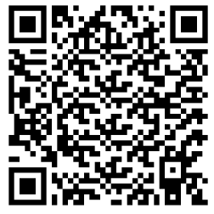
Page break

Are you looking for information, insights, or support about sexualised violence and abuse?
My Dignity – My body is mine
My Dignity is an information and reflection resource about sexualised violence. My Dignity is for anyone who may be experiencing, or has experienced, sexualised violence and for anyone who may be responding.
Wherever it is difficult to tell someone about domestic and whānau violence, it may be even more difficult to tell someone about sexualised violence. The intent of My Dignity is to provide information, support reflection, share lived experience insight from others, and signpost to contacts and supports
Read more about My Dignity
www.insightexchange.net/my-dignity/
Insight Exchange website has a safe exit button.
Page break
Are you wanting to be more prepared to respond effectively if someone shares with you their experiences of domestic and whānau violence?
Follow My Lead Aotearoa
Follow My Lead Aotearoa speaks from the voices of people with lived experience of domestic and whānau violence who need their friends, family and professionals to be more prepared to respond effectively. More prepared to respond in ways that uphold dignity and build on safety.

View the Follow My Lead Animation (4mins)
Read more about Follow My Lead Aotearoa
www.insightexchange.net/follow-my-lead
Insight Exchange website has a safe exit button
Page break
Are you wanting to read more lived experience insights?
Voices of Insight Collection
The Voices of Insight Collection is a series of original artworks inspired by the Insight Exchange Voices of Insight narratives. The initiative is designed to illuminate visual metaphors and symbols used by Insight Exchange participants as part of how they describe their lived experiences of domestic and family violence to inform social, service and systemic responses. Each of these artworks was developed by collaborating Artist Louise Whelan and is informed by the participants who shared their voices of insight.
After opening the collection, click on a specific image to open the associated lived experience narrative.
Read more about the Arts Lab
www.insightexchange.net/insight/arts-lab-collection/
Insight Exchange website has a safe exit button.

Page break
OTHER RESOURCES:

ANIMATIONS AND VIDEOS
Insight Exchange Vimeo channel vimeo.com/Insightexchange

What is domestic and family violence?
View the short Insight Exchange animation ‘What is DFV?’ (4mins) hosted on www.insightexchange.net/what-is-dfv

Read more by downloading the fact sheet: What is domestic and family violence? (PDF) hosted on www.insightexchange.net/what-is-dfv
Insight Exchange website has a safe exit button.

My Safety Kit
View the My Safety Kit Animation - An introduction for people reflecting on their relationships (2.4mins) hosted on www.insightexchange.net/my-safety-kit

An introduction to the My Safety Kit to the decision-making tool (3.5 mins) hosted on www.insightexchange.net/my-safety-kit
Page break
The simple feather design is inspired by global Indigenous communities standing in solidarity for honor, respect, and peace. The koru inserts are unique to Māori symbolism and represent new beginnings, continuityy, and connection.

Donny Riki – Ngāpuhi, Ngāti Paoa. Artist, psychotherapist and grandmother

Ēhara taku toa i te toa takitahi, ēngari he toa takitini

Whakawhiti māramatanga/Insight Exchange would like to thank all contributors, critical friends and communities, who have engaged directly or indirectly with this My Safety Kit resource.

In particular, the Insight Exchange team would like to thank Dr Linda Coates and Dr Allan Wade and their colleagues at the Centre for Response-Based Practice, Canada for their visionary and pioneering work on social responses, resistance, language, and the upholding of dignity.

Nō reira, kei te mihi kei te mihi kei te mihi maioha ki ētahi rangatira- he nui te wanawana, ka wani kē!

Most significantly, our thanks goes to all people with lived experience of Domestic and Whānau Violence who have courageously shared their insights for the benefit of others.

Ngā mihi mīharo nui, koia kei a koutou
Page break
Free electronic copies of My Safety Kit Aotearoa and short My Safety Kit animations are available on www.insightexchange.net/my-safety-kit

We welcome feedback to improve future editions. Use the link to the survey or use our Contact Us page

INSIGHT EXCHANGE

www.insightexchange.net

