Follow My Lead - Aotearoa
This resource contains descriptions of domestic and whānau violence.
This resource speaks from the voices of people with lived experience of domestic and whānau violence who need their friends, family and professionals to be more prepared to respond effectively.
More prepared to respond in ways that uphold dignity and build on safety.
Page break
E mihi: Toitū te whenua, toitū moana, toitū te manu o te tāngata o te ao nui ki te ao wairua - tēnā koutou katoa. Hāpaitia te ara tika, pūmai ai te rangatiratanga mō ngā uri whakaheke .
Greetings: Respectful acknowledgment binds together land, sea, and people of past, present and future. Foster the pathway of knowledge to strength, independence, and growth for future generations.
Page break
He take kaingākau ki ahau
“Your Response can be of immense help.”
Page break
How you respond to me when I share with you, and in the time that follows, matters significantly to me.
I might tell you parts of my experience to test out how safe I am with you and to explore how you react or retreat. “
“Sussing out who to tell and how much to tell them is important for my safety, so I will do this with caution. I will also gauge how much energy I need to invest in this encounter and decide whether or not I should even go there as often, the conversation becomes about having to defend myself while convincing you that it is the truth” Deanne, Age 32.
Page break
I’ll be looking to see;

• what you think of what I have shared
• that you believe me
• what you think of me and if/how that changes now that you know more about me
• whether you give more weight to what the person abusing me says than what I say
• whether the person abusing me will be able to influence your thinking and make you think differently about me
• and what this means next
“When I told the school counsellor she said I couldn’t talk to her about that stuff because it meant I had a mental condition. I didn’t want to talk to her again after that, she just made me feel bad” Moana, Age 13
Page break
E ora ana ahau i a koe? Are you prepared to respond safely if I share with you?
I have already lived a lifetime of prejudice and wonder how much of my experience I need to dilute to make it more palatable for you. I want you to be different to others I have talked to, see me with your gentle spirit and listen deeply with your heart” – Hereata, Age 29.
Page break
Being safe is no simple or single decision, or task.

A good first step is to learn more about my world and how the violence harms my safety and wellbeing.

Ma te whakapono, ma te tūmanakō
Ma te tītiro, ma te whakarongo
Ma te ako tahi, ma te manawanui
Ma te aroha, ka taea e au

With hope comes faith, with seeing comes listening, with curiosity we learn together our hearts grow, and with love you will fully see who I am.

”My nan says it takes a thousand cups of tea to get to know someone well enough to trust them – she has a really big teapot!” Riria, Age 31.
Page break
Domestic and whānau violence is an injustice and is an offence to my dignity, compromising my safety and undermining my wellbeing… and the dignity and wellbeing of the people I care for and who care for me.

Ki te Atua ko ngā tāngata katoa i te whānaungatanga e wātea ana, ā, e tauriterite ana te tū rangatira me te mana tangata

According to the lores of creation, all human beings are born free and deserving of dignity and self-authority.

“That means I have the right to live a life that is free from fear and oppression, the right to be treated respectfully and the authority to speak my own language” Georgina, Age 74.

Page break
He māhere tēnei ō tōku oho

How you and I view things is personal and unique and can change over time.

I would like you to understand that I know my world best; what it has been, what it is now and what it might become.

Ka koekoe te tūī ka ketekete te kākā, ka kūkū te kereru - ka karanga atu tātou, ā, āhua rite he rerekē rānei

This proverb speaks about the importance of hearing each others voices and opinions while acknowledging diversity and uniqueness, as it takes all sorts of people to make important contributions
Page break
I know you want to help but if you oversimplify my world so that you can feel you understand, you lose sight of my challenges and my capacities.

Read on to watch my world build.

This is a map of my world: it’s complex.

A message to service providers:

“I often look outwards to the social world and the natural world to make meaning. I am shouldered up by ancestors and blessed with the breath of the gods. So, my world view may be very different to yours. There are many layers of violence I am responding to every day and you may only see the current inter-personal violence that is afflicting me. I also live with structural violence like oppression, racism and sexism as well as inter-generational and historical violence. Most encounters I have with non-Māori are microaggressions which are profound, spiritual and invisiblised” Jo, Age 57.
Page break

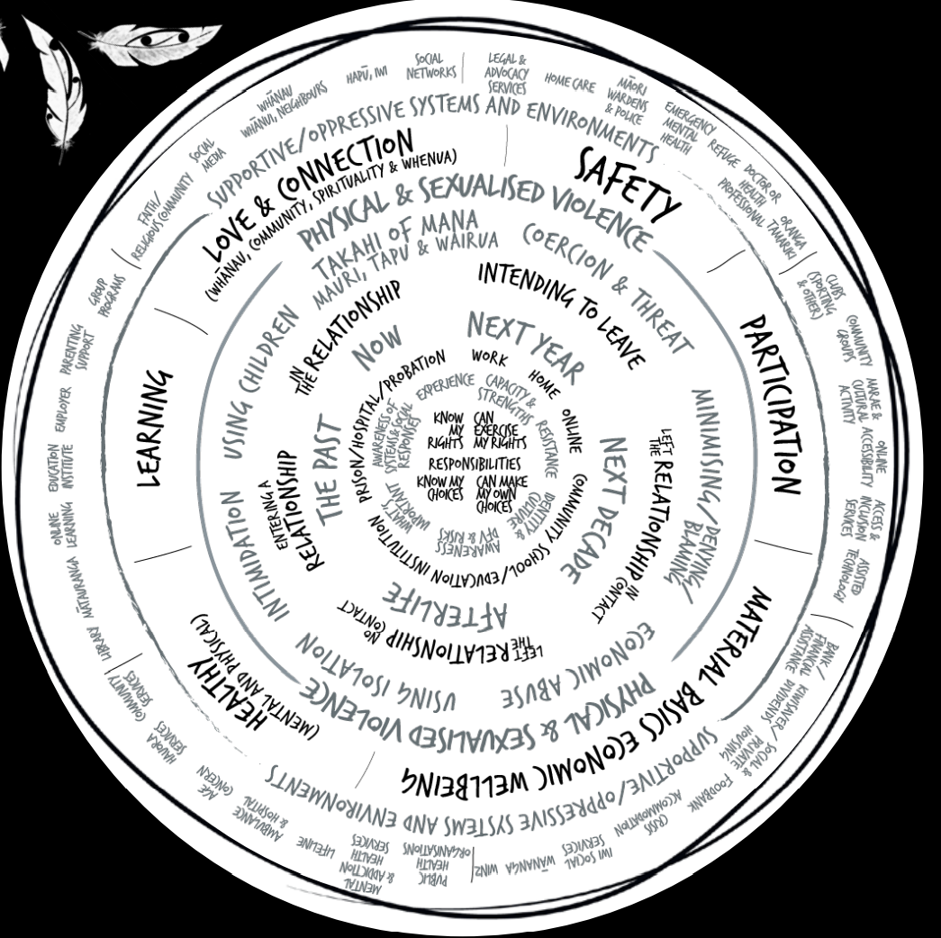
Page break

I am a unique person with unique experiences.

I have rights and responsibilities.

I respond to events and exercise choice. But violence and coercive control limit my options

He kākano ahau i ruia mai i Rangiātea

“I am a seed born of greatness, and carry the wisdom and knowledge of my ancestors.”.

“Knowing about my culture and where I come from makes me feel so proud, like I can do anything… it really helped me let go of the anger I had towards my dad – I reckon if he knew where he came from, he would have stopped bashing mum years ago”- Lydia, Age 15

Page break
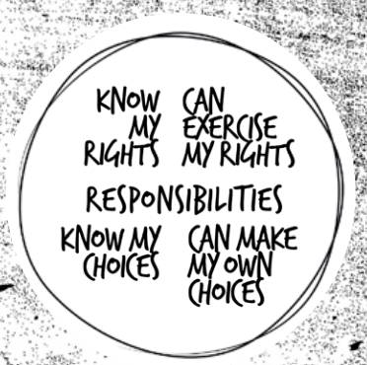

Page break

Tino Rangatiratanga | Mana Motuhake

I have my own sense of what is important right now and in the long term.

I identify with and belong to many communities and networks.
These are the contexts in which I understand and respond to Domestic and Whānau Violence.

I respond to, and resist, the violence, discrimination and oppression in my own way despite danger and unpredictability.

I am always aware of the actual and possible responses of others, from professionals to my friends and whānau members.

These responses inform how, or if, I reach out to others. “
Page break

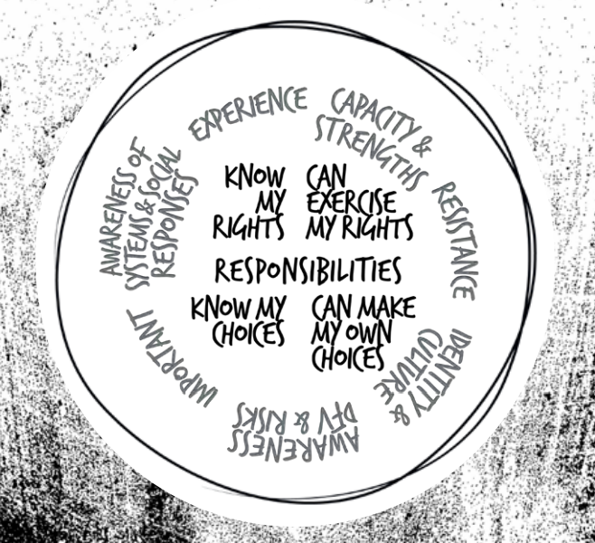

Page break

Mana whakahaere

Where I am (at home, in school, online, on my mobile, at work, in prison, in hospital, on probation, in the community) changes the risks I face and the responses I can expect to receive.

I anticipate and respond to threats and risks wherever I go, with whoever I meet and whatever I do.

Mā te huruhuru ka rere te manu

Adorning me with feathers empowers me to fly.

Page break

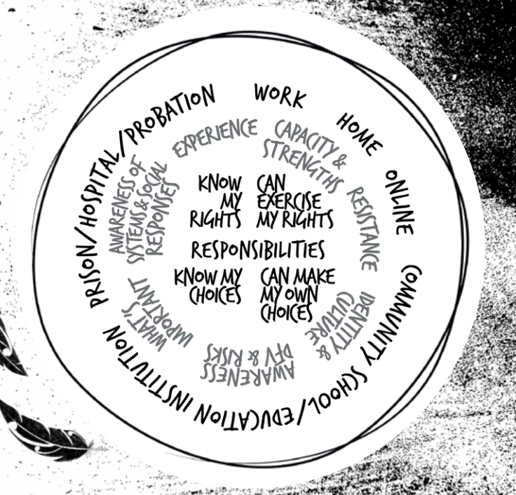

Page break

Te ao hurihuri

The risks I face change over time and can change rapidly.

The abuse I have experienced in the past might be similar or different to the current or future threats I face.

The importance I place on the past, the present, the future, and possibly the afterlife, can influence how I see things and make decisions.

Something that makes me safer in the short term might make me less safe in the future.

These facts may be seen or unseen by others, however they are personal and make sense to me.

Ka oho te wairua ka matāra te tīnana, he aroha ki te aroha, ka kā te rama

When the spirit is awakened, when the body is alive, when love is unconditional, wellness is possible.

“The world is always changing and I must always adapt how I respond to it. I am grateful that land is permanent, mountains are permanent and sea is permanent. This gives me a feeling of familiarity and security.” – Lisa, Age 33
Page break
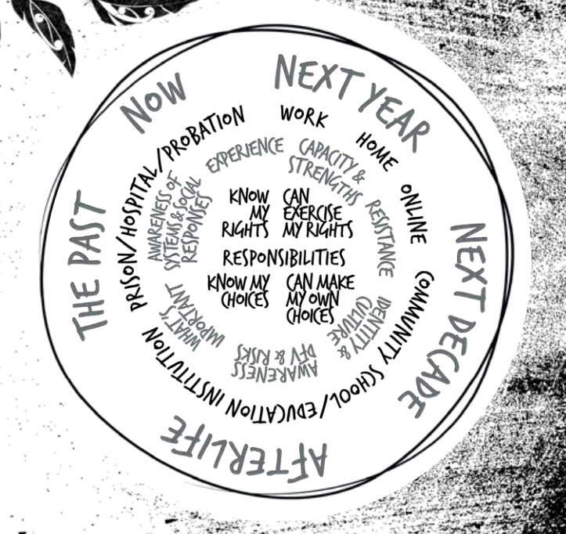

Page break

Whānaungatanga

The status of my relationship matters. My relationship status with the person abusing me creates different levels of risk, threat and consequences for my dignity and wellbeing.

I might be entering a new relationship, in a relationship with no intention to leave, or planning to leave when I can. I might have escaped but am threatened and forced back into contact with the person abusing me because of the children (or pets, or some other reason). I might have no contact with the person abusing me but know I will (or may) be unsafe if found.

The person abusing me may change the nature of their behaviour rapidly, without warning, significantly changing the realities I face.

I might be in relationships with more than one person who is committing violence against me. It is my choice whether I am in a relationship and whether I choose to leave it.

Waihō i te toipoto, kaua i te toiroa

Relationships are as important as the people who nurture them for they define who we are, how we make sense of the world and where we self-locate.
Page break

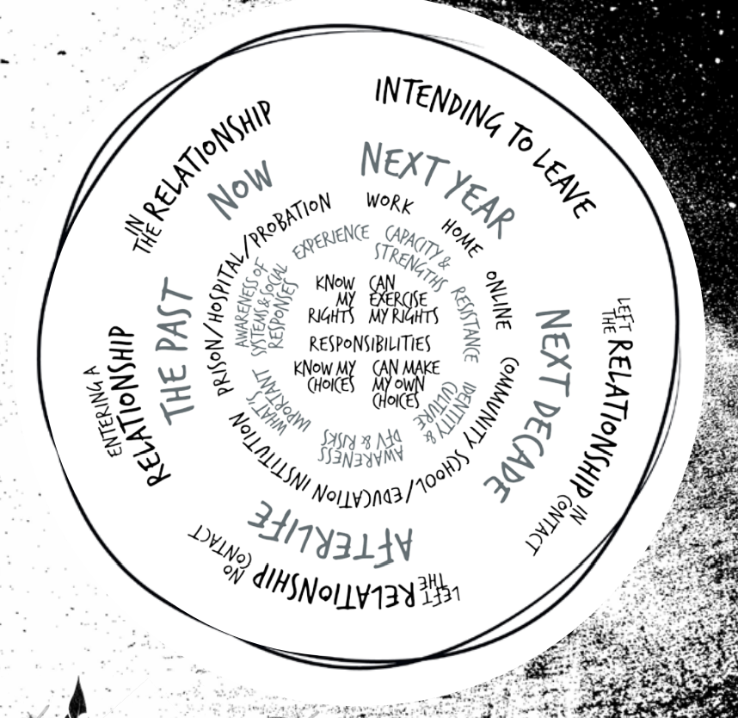

Page break

Te mahi tūkino
Just as every person is unique, the violence I experience is unique.

I may be threatened, intimidated or coerced into doing things against my will.

The person committing the abuse may isolate me from those I love and manipulate others against me, and undermine my relationships including my parenting.

They may commit physical, verbal, emotional or sexualised abuse, and they may threaten or abuse my children, friends or whānau, pets, property, and things that are important to me as a means to control me. They may steal, control or undermine my finances, or my ability to work or be financially independent.

They may try to use my beliefs and spirituality to control and isolate me.

I am experienced in anticipating the patterns and tactics that the person abusing me uses against me and the people I care about. I can see how they adjust their tactics to supress my resistance and responses to their abuse.

The actions of the person who has abused me may be similar to others but are also completely unique and specific to me and those whom I love.

Iti noa he pito mata

No matter how subtle it may seem, it has the potential to transform into something else.

This proverb can be used to illustrate the perpetrator of violence, the responder to violence or the structures that uphold it
Page break

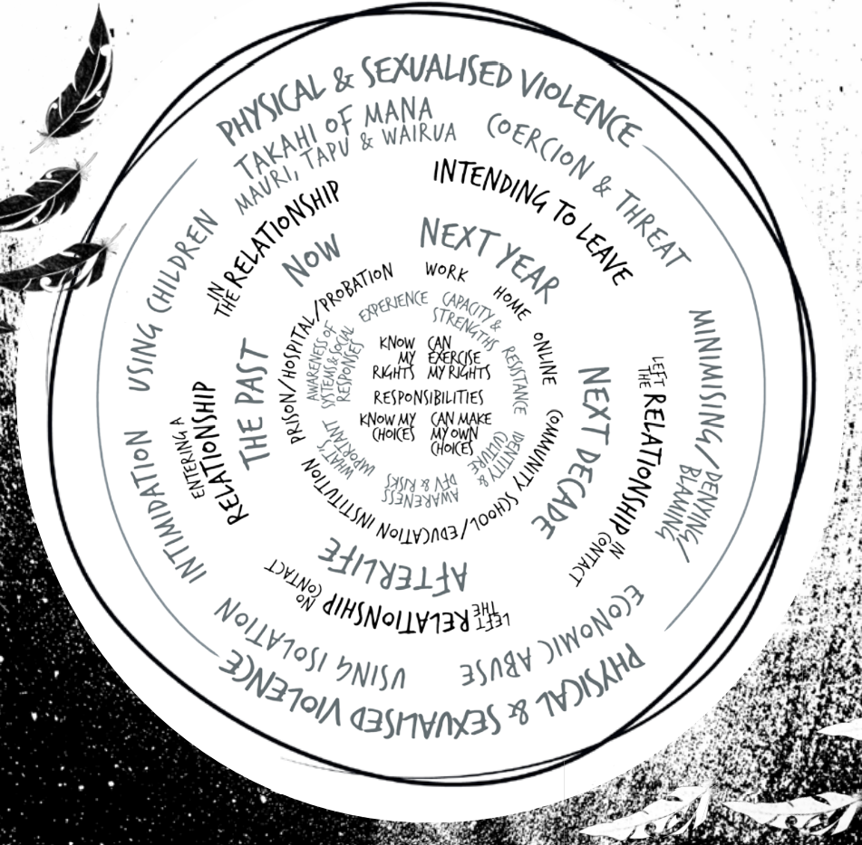

Page break
Te pōuri o tōku ngākau i te mahi tūkino
The violence I experience undermines my wellbeing across many areas of my life.
My responses – the person using violence violates my rights, restricts my choices, and limits my capacity to act and put into force my own decisions.
My safety – my safety is compromised.
Love and connection - my whānau relationships, friends and connections with community, spiritual connection and connections to land may be under threat.
My learning and growth – because I am forced to deal constantly with abuse, and possibly with negative responses from others, I experience fatigue and isolation. Sometimes I cannot help but ignore or avoid activities that could help me learn and develop as a person because of competing priorities related to violence.
My health – my body and mind suffer from the violence and coercion. I can become physically unwell, fearful, desperate, lonely, sad, and angry.
Although my despair is one form of resistance to the violence, I may be seen as ‘clinically depressed’ or as having another disorder. My feelings are ethical emotional responses to violence.
My material basics and economic wellbeing – the person abusing me tries to suppress my resistance by limiting my access to material and economic basics, such as food, housing, clothing, money and my financial assets. If they can undermine my material and economic wellbeing, they will be more able to use violence.
My participation – my opportunity to participate, have a voice and be involved as a citizen and in the community may be limited.
Page break
“ The violence I experience is an affront to my dignity.”
Mai i te kōpae ki te urupā, me whawhai tū tonu e au hei whakamāna
From the cradle to the grave, we fight to uphold our dignity and integrity.
Page break
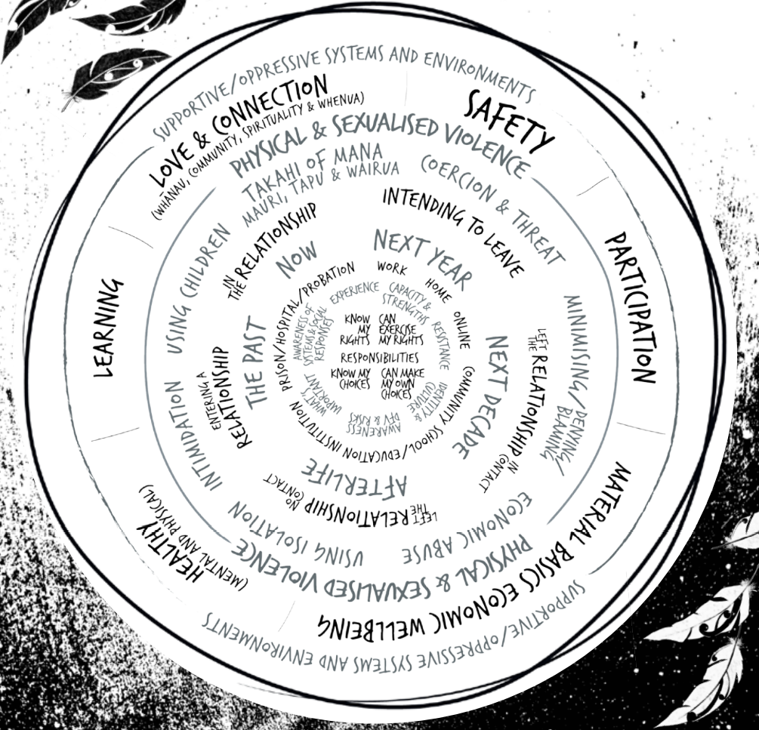

Page break

Tukua kia rere me whakarere noatia

I may experience supportive, unsupportive or oppressive systems and environments.

My race, gender, sexuality, class, immigration status, ability, age etc. influences the circumstances of my life and the discrimination and oppression I may experience.

When I face multiple forms of discrimination, the person abusing me is empowered to use greater levels of violence and I am isolated from formal and informal support systems.

I may receive both positive and negative social responses from others.

The quality of the social responses I have received influences ‘if’ and ’how’ I engage with social networks and services.

The decisions I make and if/how I take steps is influenced by my context, situation and the coercive control I am experiencing.

Despite this complexity, and even when under immense pressure, I also consider how my decisions to act or not act, may impact the experiences of people and communities I care about.

K Crenshaw (1991) mapping the margins: intersectionality, identity politics, and violence against women of color.
Page break

Me kōrero tahi tāua

I resist and respond to the violence, discrimination and oppression I experience.

I do this in visible and invisible ways that might not seem obvious or directly related to what is going on, but these responses and forms of resistance to violence are important to me, and are part of upholding my dignity.

The person abusing me knows that I do not like the violence and anticipates that I will resist. Consequently, I must hide my resistance, sometimes completely, and find a safe place in the privacy of my mind.

Page break

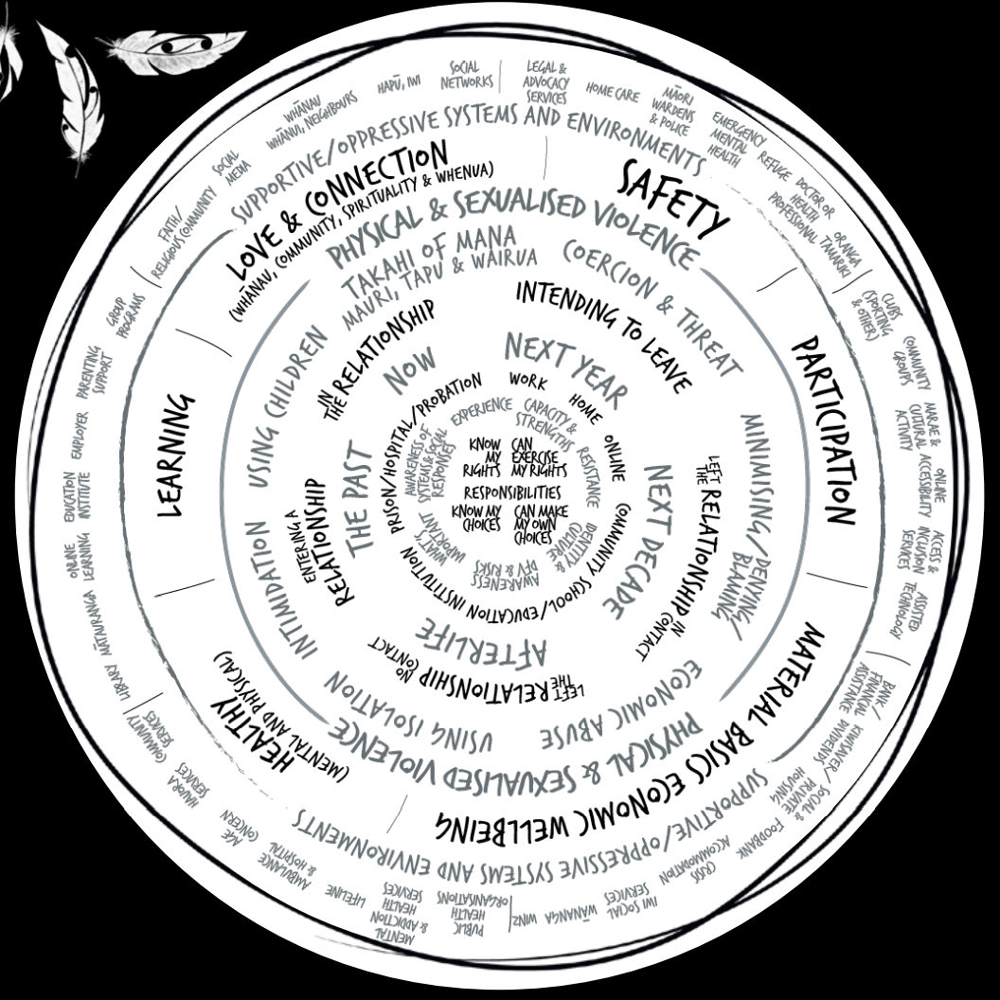

Page break

He kōrero tahi tāua ināianei?

How ready are you to respond if I do share with you?

“One step to becoming more ready to respond, is to understand what your response might mean to me - how your response can help or how it could harm.”

Page break

Please recognise that I am already active in resisting the violence, building safety for myself and others, and managing risk. I am constantly...

• Assessing for safety and watching for changes in risk, and anticipating risk.

• Building safety awareness, through intuition, information, and experience.

• Inventing and implementing ways (tactics/strategies) to keep myself and the people I care about safe.

Page break

Please remember, there may be much more going on than I care to say - until I know you’re safe to share with.

If you try to make decisions for me and tell me what to do, I might feel more unsafe than before I shared with you.

I may not know what I want you to do, I may want you to do nothing, I may want you to do something. I may want your quiet support alongside me, or I may want you to do something proactive, or a mix of these things.

Page break

Listen to me and follow my lead.

Let me decide what’s needed and what’s next.

Let me lead the pace and the precision of any steps.

Let me lead.

All of this may take time.

He ora te whakapiri me whakarongo He mate te whakakūware

There is strength in unity, and defeat in division.

Page break

DEFINITION

Domestic and whānau violence includes any behaviour, in an intimate or whānau relationship, which is violent, threatening, coercive or controlling, causing a person to live in fear and to be made to do things against their will.

Domestic and whānau violence can happen to anyone and can take many forms. It is often part of a range of controlling or coercive behaviours.

An intimate relationship refers to people who are (or have been) in an intimate partnership whether or not the relationship involves or has involved a sexual relationship, i.e. married or engaged to be married, separated, divorced, de facto partners (whether of the same or different sex), couples promised to each other under cultural or religious tradition, or who are dating.

A whānau relationship has a broader definition and includes people who are related to one another through blood, marriage or de facto partnerships, adoption and fostering relationships, sibling and extended whānau relationships. It includes the full range of whānau, hapū & whānau whanui, and whānau of choice within takatāpui and fa’afafine, lesbian, gay, bisexual, transgender, intersex and queer (LGBTIQ+) communities.

People living in the same whare, people living in the same residential care facility and people reliant on care may also be considered to be in a domestic relationship when one or both people in the relationship try to create an imbalance of power to establish coercive control and commit violence

Definitions of violence have broadened over the years to include spiritual, historical and intergenerational violence. Colonial violence is characterised by extensive acts of violence upon Māori - understanding both the strategic nature of colonisation and historical violence is critical to understanding the origins of whānau violence in Aotearoa.
Page break

The behaviours that may represent Domestic and Whānau Violence include:

• Physical violence including physical assault or abuse

• Sexualised violence encompassing all behaviours used by a perpetrator to threaten, coerce, violate, or force the targeted person (victim) into sexualised activity

• Reproductive coercion

• Emotional or psychological abuse including verbal abuse, threats of violence, threats of self-harm or suicide, blackmail and bribery

• Economic abuse; for example denying a person reasonable financial autonomy or financial support

• Stalking; for example harassment, intimidation or coercion of the other person’s whānau in order to cause fear or ongoing harassment, including through the use of electronic communication or social media
• Kidnapping or deprivation of freedom, as well as unreasonably preventing the other person from making or keeping connections with their whānau or kin, friends, faith or culture

• Damage to property irrespective of whether the victim owns the property

• Causing injury or death to an animal irrespective of whether the victim owns the animal.

• Language coercion: being forced to speak English

• Spiritual coercion: Isolation from tribal lands, sacred mountains and waterways. Denial of moko kauae, matāora or tā moko. Denial of matekitetanga, iwitanga and ancestry

• Religious coercion: Being forced to join a religious group or attend church.

• Medical coercion: Denial of rights to see a GP or tohunga (traditional healer), take medication or rongoā

• Inter-tribal transgressions: Ancestral conflicts of dominance

• Body snatching: Cultural rites are denied and tūpāpaku (deceased) is stolen to be buried elsewhere

• These acts of violence are deliberate, unseen and unspoken outside of Māori communities but occur very regularly. While many Māori people force their whānau to assimilate to Pākeha ways, others force their whānau to decolonise themselves
Page break

Women and children are overwhelmingly the victims of Domestic and Whānau Violence and those who use violence are overwhelmingly male.

Domestic and Whānau Violence can be perpetrated by a partner, whānau member (including children perpetrating violence against their siblings or parents), carer, flat mate, boyfriend or girlfriend.

Women also commit Domestic and Whānau Violence against men, as do same-sex partners. Domestic and Whānau Violence is also committed by and committed against people who identify in non-gender binary terms.

Examples of lived experiences and implications of sexualised violence:

“Back in the day, if a woman or child was violated, it was the worst offence anyone could commit. The man would be ostracised from the tribe, and his rights and possessions were given to the victim’s family. He was stripped of his mana, gees…. that was a fate even worse than death” Uncle Fraser, Age 82.

“Protecting whakapapa - ancestral lines, is so important. That’s why we bury the whenua (afterbirth) in the earth – so that we can reconnect with Papatūānuku (our earth mother) when we die. Women who are raped need to heal these connections, so that they can rejoin their ancestors in the spirit world. Aue, taukiri e!” Aunty Piki, Age 70.

“It is not ‘just the woman’ who is violated, but it includes all of the women in her ancestral line too. That’s how the spiritual pain becomes inter-generational. That’s why healing is so important” Nanny Kaimanu, Age 77.

“A social responder is any person who is knowingly or unknowingly responding to those who are directly involved in cases of violence – those who perpetrate violence and those who are victimized.”

Ref: Wade, 2014 (Where the hell is everybody?) and (Coates and Wade, 2016) ‘We’re in the 21st Century After All’: Analysis of Social Responses in Individual Support and Institutional Reform.
Page break
AOTEAROA | NEW ZEALAND CONTACTS
If you are in immediate danger, call 111 and ask for the police.
If not safe to speak, push 55 on a mobile (any number on a landline) to be put through to Police.

Age Concern Elder Abuse Helpline
P: 0800 32 668 65 - 24 hours
W: www.ageconcern.org.nz/
Content: Information and contacts

Are you OK?
P: 0800 456 450 (9 am – 11 pm) 7 days
W: www.areyouok.org.nz
Content: Information and contacts

Kokiri marae – affiliated Māori women’s refuge
P: 04 566 5025 - 24 hours
W: https://takirimai.org.nz/KōkirimaraeMāoriWomensRefuge
Content: Information and contacts

National Network of Stopping Violence Services
P: 03 391 0048 Office hours
W: https://nnfvs.org.nz/
Content: Information and Contacts

New Zealand Police
P: 111 - 24 hours
W: www.police.govt.nz/advice/family-violence/help
Content: Information and Contacts

Women’s Refuge
P: 0800 733 843 - 24 hours
W: https://womensrefuge.org.nz
Content: Crisis line

Community Law
Family/domestic violence and civil/family legal aid. Rape, sexual assault, and family (domestic) violence.
Visit website for Reginal contacts - Office Hours community
W: https://law.org.nz
Content: Free Legal Advice

Pasefika Proud
Visit website for Regional contacts
W: www.pasefikaproud.co.nz/
Content: Information and Contacts

Find sexual assault support near you
Visit website for Regional contacts
W: https://sexualabuse.org.nz/resources/find-sexual-assault-support-near-you/
Content: Reginal contacts and Information

Get Help TXT or Call
P: 1737 - 24 hours
W: N/A
Content: Anytime text or call General Helpline

Shakti
P: 0800 742 584 - 24 hours
W: https://mherc.org.nz/directory/all-listings-alphabetical/shakti-crisis-line/visit
Content: For migrant and refugee women (multi lingual)

Shine
P: 0508 744 633 – 24 hours / 7 days
W: https://www.2shine.org.nz/
Content: Confidential Helpline
Te puna ōranga
P: 03 381 8472 (Mon – Fri) 9am – 5pm
W: https://mherc.org.nz/directory/all-listings-alphabetical/te-puna-oranga
Content: Information and contacts

Te whare rokiroki – Māori women’s refuge
P: 04 802 5898 0800 733 8430 - 24 hours
W: http://www.tewharewhanaupurotu.org.nz/
Content: Information and contacts

What’s Up
P: 0800 942 8787 (Mon-Fri 12pm-11pm Sat/Sun 3pm-11pm)
W: https://www.whatsup.co.nz/
Content: A safe place for you to talk about anything at all

Page break

INSIGHT EXCHANGE

Insight Exchange centres on the expertise of people with lived experience of domestic and whānau violence and gives voice to these experiences.

Insight Exchange is designed to inform and strengthen social, service and systemic responses to domestic and whānau violence.

www.insightexchange.net

Launched in November 2017, Insight Exchange was designed by Domestic Violence Service Management (DVSM), in collaboration with Dr Linda Coates and Dr Allan Wade from Centre for Response-Based Practice, Canada.

Insight Exchange has been established, developed and is governed by Domestic Violence Service Management (DVSM) a registered charity (ABN 26 165 400 635).

Insight Exchange has been sustained through the generous donations of individuals and a silent donor for the benefit of many.

Copyright and using this resource: The information contained within this resource is for general information purposes only. Insight Exchange assumes no responsibility for how the information in this resource is used.

Read more about Using Insight Exchange www.insightexchange.net/guide-using/

Insight Exchange is for all people. Insight Exchange respects the diversity of all sexualities and gender identities including but not limited to; Lesbian, Gay, Bisexual, Transgender, Intersex, Queer and A-Sexual + identities as well as Heterosexual and Cisgender identities.

EXPLORE INSIGHT EXCHANGE RESOURCES

Scan the QR code to open Insight Exchange.
Privacy: This is a static QR code to eliminate any collection of your data when scanning.

Insight Exchange website has a safe exit button

Page break
Are you feeling uneasy, worried, unsafe, exhausted, fearful or confused about what’s going on in your relationship, and what might happen next?
My Safety Kit Aotearoa
My Safety Kit Aotearoa is a reflection resource that speaks in the voice of the reader who may be reflecting on their own relationships and (possible) experiences of domestic and whānau violence.
The resource may also have benefits for people who are supporting friends and family who are (or might be) experiencing domestic and whānau violence; and for people who are working as a service responder to people experiencing domestic and whānau violence.
Read more about My Safety Kit
www.insightexchange.net/my-safety-kit
Insight Exchange website has a safe exit button
Page break

Are you read more insights from peoples lived experience?

Voices of Insight Collection

The Voices of Insight Collection is a series of original artworks inspired by the Insight Exchange Voices of Insight narratives. The initiative is designed to illuminate visual metaphors and symbols used by Insight Exchange participants as part of how they describe their lived experiences of domestic and family violence to inform social, service and systemic responses. Each of these artworks was developed by collaborating Artist Louise Whelan and is informed by the participants who shared their voices of insight.

After opening the collection, click on a specific image to open the associated lived experience narrative.

Read more about the Arts Lab

www.insightexchange.net/insight/arts-lab-collection/

Insight Exchange website has a safe exit button
Page break

Are you looking for information, insights, or support about sexualised violence and abuse?

My Dignity – My body is mine

My Dignity is an information and reflection resource about sexualised violence. My Dignity is for anyone who may be experiencing, or has experienced, sexualised violence and for anyone who may be responding.

Wherever it is difficult to tell someone about domestic and whānau violence, it may be even more difficult to tell someone about sexualised violence. The intent of My Dignity is to provide information, support reflection, share lived experience insight from others, and signpost to contacts and supports.

Read more about My Dignity

www.insightexchange.net/my-dignity/

Insight Exchange website has a safe exit button
Page break

Ēhara taku toa i te toa takitahi, ēngari he toa takitini

Whakawhiti māramatanga/Insight Exchange would like to thank all contributors, critical friends and communities, who have engaged directly or indirectly with our Concepts of Safety Project and this Follow My Lead resource.

In particular, the Insight Exchange team would like to thank Dr Linda Coates and Dr Allan Wade and their colleagues at the Centre for ResponseBased Practice, Canada for their visionary and pioneering work on social responses, resistance, language, and the upholding of dignity.

Wade. A. (1997) Small Acts Of Living: Everyday Resistance To Violence And Other Forms Of Oppression. Contemporary Whānau Therapy 19 (1) March 1997

Nō reira, kei te mihi kei te mihi kei te mihi maioha ki ētahi rangatira - he nui te wanawana, ka wani kē!

The simple feather design is inspired by global Indigenous communities standing in solidarity for honor, respect, and peace. The koru inserts are unique to Māori symbolism and represent new beginnings, continuity, and connection.

Donny Riki – Ngāpuhi, Ngāti Paoa. Artist, psychotherapist and grandmother
Page break

This is the collective work of many hands.

Most significantly, our thanks go to all people with lived experience of domestic and whānau violence who have courageously shared their insights for the benefit of others.

Ngā mihi mīharo nui, koia kei a koutou

Free electronic copies of Follow My Lead are available and online and we welcome continued feedback in order to learn about the value of this resource and to improve future editions. Access the online version and read the background context about the development of Follow My Lead Aotearoa via www.insightexchange.net. Provide your de-identified feedback using this www.surveymonkey.com/r/FMLAotearoaNZ

Insight Exchange & RBPAotearoa uphold Tino Rangatiratanga in partnership with Māori – the generations who have gone before, and the generations yet to come. We extend this respect to all Indigenous peoples. We acknowledge Sovereignty was never ceded.

www.insightexchange.net
INSIGHT EXCHANGE

