My Safety Kit
This resource is designed to support the reflections of people who are, or may be, experiencing domestic and family violence.
Page break
Insight Exchange acknowledges the Traditional Custodians of the land on which our work and services operate and pay our respect to Elders past and present. We extend this respect to all First Nations people across the country and the world. We acknowledge that sovereignty of this land was never ceded. Always was, always will be aboriginal land.

SUPPORTS
Please note My Safety Kit is a resource not a service response. A range of supports and resources are listed in this resource. See Page 32 onward.

My Safety Kit is for all people. Insight Exchange respects the diversity of all sexualities and gender identities, including but not limited to; Lesbian, Gay Bisexual, Transgender, Intersex, Queer and A-Sexual + identities as well as Heterosexual and Cisgender identities.

IN AN EMERGENCY
In Australia, call Triple Zero (000)
In New Zealand, call Triple One (111)
Page break
One thing, or a whole lot of things, might not be right for me in my relationship.
I might be feeling uneasy, worried, unsafe, exhausted, fearful or confused about what’s going on and what might happen next.
I might want to talk with someone about what’s going on. I might want to talk through my thinking and the questions I have been working through in the privacy of my mind.
My Safety Kit is designed to support me (at my pace), with information and reflection questions about how I see things and what I might be thinking about, when looking ahead.
My Safety Kit is designed to build on my:
• existing safety awareness
• self-assessment of my safety
• existing safety strategies with possibly some new/extra ideas.

A healthy relationship includes equality.
The features of a healthy relationship apply to all types of relationships, including friendship, family, work relationships and intimate partners.
My Safety Kit is designed to support me to reflect on these questions:
• What did I hope for and what is going on in this relationship?
• What kinds of things am I having to do to stay safe and well?
• How constricted has my life become?
• Why is this happening? Is it me?
• What decisions are important to me about my safety, liberty and wellbeing?
• What is available to me and who can support me?
• What is domestic and family violence?

Page break

What did I hope for and what is going on in this relationship?

Page break
Honesty is possible where there is safety.
I am wondering about some things…
Are my rights and boundaries respected?
Are we sharing the work in the relationship?
Are we both included in making decisions?
Am I able to safely express my thoughts and feelings?
Is there safety for everyone – enough to allow comfort and some discomfort?
Can I safely talk about what I am and am not comfortable with?
Can I be open and honest about my intentions, feelings or desires?
Do we each take responsibility for our own actions?
Can I trust they will respect me and be honest and supportive?
Do I have the support and encouragement to achieve my goals and dreams, and personal growth?
There is no place in a healthy relationship for controlling, abusive and violent behaviour.
Page break
My wellbeing
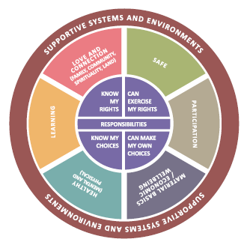
“My wellbeing - and that of my children - matters to me and this includes my safety.
Being ‘safe’ is more than being physically safe – it includes all aspects of my wellbeing.
Each area of my wellbeing will also change over time as my needs, priorities and circumstances change.
Violence I experience can undermine my wellbeing across many areas of my life.”

Page break
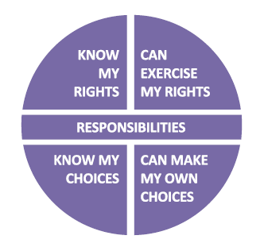
“The person using abuse and violence violates my rights and restricts my choices, and limits my capacity to act and put into force my own decisions.”
“I have the right to:
• live in peace and security, free from violence and abuse
• seek support
• be given information about things that impact me
• be asked for my consent and for my information and experiences to be managed with confidentiality
• be treated respectfully and with dignity
• make my own choices and decisions.
I have ‘agency’ and the capacity to act effectively.
When I am more aware of my rights and options, I am more able to make informed choices.
My choices are not only informed by my rights but also by my responsibilities (which may be linked to my civil, cultural, family, spiritual values).”

Page break
What kinds of things am I having to do to stay safe and well?
How constricted has my life become?

Page break

I am already active in resisting the violence and abuse, building safety for myself and others, and managing risk.
I am constantly...
- Self-assessing my safety and watching for changes in risk, and forecasting risk.
- Building my safety awareness through information and experience.
- Inventing and implementing ways (tactics/strategies) to keep myself and the people I care about safe.
Page break
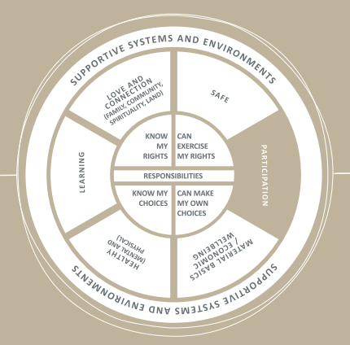
Participation
“My opportunity to participate, have a voice and be involved as a citizen, in the community and in my family, may be limited
Page break
- What kinds of things am I having to do to enable my safe participation in society, community and family? And my children’s participation?
- What kinds of things am I having to avoid doing to stay safe in relation to my participation in society, community, and in my family?
- Who knows about my circumstances, and supports my responses?

Are things changing? Do I want to talk to anyone about this? Do I want something to change?

Page break
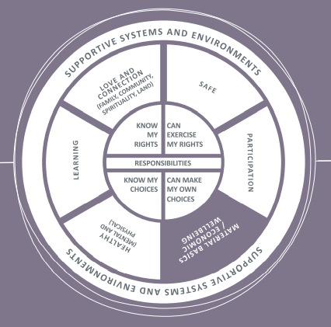
Material Basics / Economic Wellbeing
“The person abusing me tries to suppress my resistance by limiting my access to material basics, such as food, housing, clothing, and money, as well as assets and economic opportunities including study or employment.
If they can undermine my material and economic wellbeing, they will be more able to use violence.”

Page break
- What kinds of things am I having to do to ensure I have access to material basics and support for my economic wellbeing?
- What kinds of things am I having to do to provide for my children’s and help them to stay safe and well?
- Who supports me in taking the steps I need to take?

Are things changing? Do I want to talk to anyone about this? Do I want something to change?

Page break
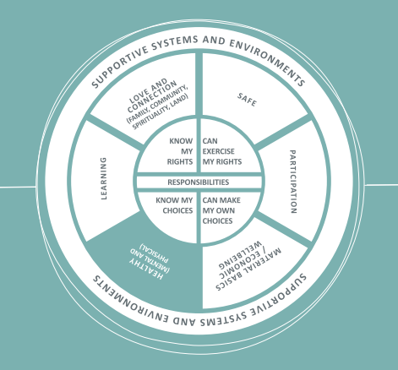
Health (mental and physical)
“My body and mind suffer from the violence and coercion. I can become physically unwell, fearful, desperate, lonely, sad, and angry.
Although my despair is one form of resistance to the violence, I may be seen as ‘clinically depressed’ or as having another disorder. My feelings are ethical emotional responses to violence.”

Page break
- What kinds of things am I having to do about my physical and mental health to stay safe and well?
- What kinds of things am I having to do about my children’s physical and mental health for them to stay safe and well?
- Who understands I am not “ill” but suffering from violence?

Are things changing? Do I want to talk to anyone about this? Do I want something to change?

Page break
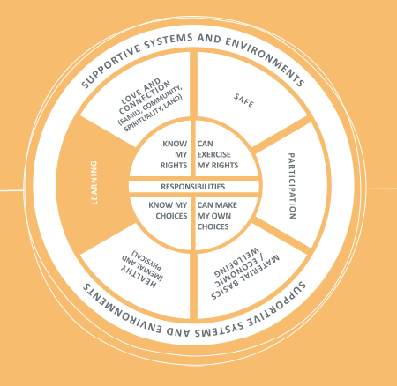
Learning
“Because I am forced to deal constantly with violence and abuse, and possibly with negative responses from others, I experience fatigue and isolation.
Sometimes I cannot help but ignore or avoid activities that could help me learn and develop as a person because of competing priorities related to violence.”

Page break
- What kinds of things am I having to do, or not do, about my learning and personal growth to stay safe and well?
- What kinds of things am I having to do about my children’s learning and growth for them to stay safe and well?
- What kinds of things am I forced to do, to deal with negative responses from others?

Are things changing? Do I want to talk to anyone about this? Do I want something to change?

Page break
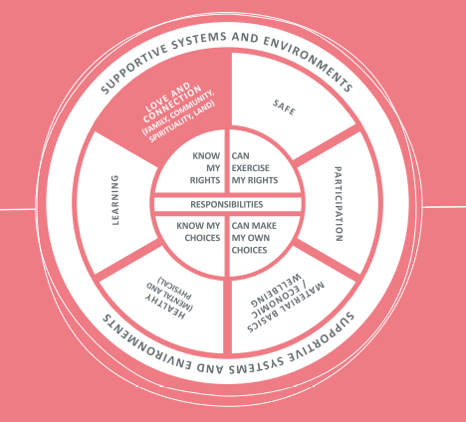
Love and Connection (Family, Community, Spirituality, Land)
“My family relationships, friends and connections with community, spiritual connection and connections to land may be under threat.
The person committing the abuse may isolate me from those I love and manipulate others against me, and undermine my relationships including my parenting. They may threaten or abuse my children, friends or family, pets, property, and things that are important to me as a means to control me. They may try to use my beliefs and spirituality to control and isolate me.”

Page break
- What kinds of things am I having to do about my relationships and connections to stay safe and well?
- What kinds of things am I having to do about my children’s relationships and connections for them to stay safe and well?
- How am I remaining connected to others and to what I know is right? Even if only in the privacy of my heart and mind?

Are things changing? Do I want to talk to anyone about this? Do I want something to change?

Page break
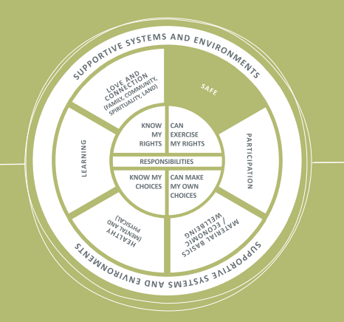
Safe
“I don’t like what is going on. I am resisting and responding to the abuse, trying to manage it. I didn’t attract it, I don’t accept it, but I can’t stop it.
My safety is compromised, and I may be in danger of physical harm or being injured or killed.”

Page break
- What kinds of things am I having to do to stay safe?

- What kinds of things am I having to do to support my children’s safety?

- What responses from others make me less safe or more safe?

Are things changing? Do I want to talk to anyone about this? Do I want something to change?

Page break
“It is my right to be informed so that I can make informed choices and decisions about experiences and opportunities that relate to me and my children”

The NSW government uses the Domestic Violence Safety Assessment Tool (DVSAT) to ask about ‘known’ risk factors relating to ‘danger’. Other states and territories may use similar or different sets of questions for the same purpose.tinyurl.com/NSW-DVSAT
These questions might be used by some of the services you may seek support from. The risk factors in the list are not exhaustive or conclusive.
The items listed may indicate that greater risk of physical harm is possible, particularly where multiple factors are occurring or intensifying.
You know your experience best; what it has been, how things are and what might happen next or if you change things. Talking about your experience can help to reveal the kind of danger you might be in, and the injustice you are experiencing.
When you share details about how you have been resisting and responding to the abuse and violence this can help to reveal how deliberate the abuse and violence is and how it is costing you and your children.

Page break

Why is this happening? Is it me?

Page break

“I have been thinking about what is happening in my life and what it all means”
It’s your life and you are closest to what is going on. You are experienced in anticipating the patterns and tactics that the person abusing you uses against you, and uses against the people you care about.
You can see how the person abusing you adjusts their strategies to suppress your resistance and responses to their abuse.
Their actions to abuse you may be similar to what others experience, but are also completely unique and specific to you and the people you love.

“I have been wondering if the person abusing me is in control of what they are doing”
With rare exceptions, violence is deliberate. It, requires intentionality, effort, and choice to be violent and abusive. The person might say they don’t want or mean to hurt or harm you, yet they do.
When they make excuses for how they abuse you, that tells you that they know it is wrong. That’s why they hide it from others or hide their behaviour behind excuses.

Page break
“I have been wondering if the violence and abuse is my fault”
You are not experiencing violence because of a personality type or characteristic you have. You don’t ‘attract’ abuse. You might not be able to stop the violence and abuse but that doesn’t mean you ‘let it happen’.

“I have been thinking about whether I could have done more, or could be doing more, to make it stop”
The responsibility to stop the violence rests with the person being abusive - even if the community and social media around you seem to suggest it is up to the victim of abuse to reduce, stop or escape the violence.
Everyone experiencing violence, resists and responds to the violence in their own ways. You might respond in ways that you hide from view and opinion in case you experience more judgement, danger or harm.
What you do may not always make sense or seem logical to people around you, but you are doing all you can with what you can, to create safety, avoid humiliation and more loss.

Page break

What decisions are important to me about my safety, liberty and wellbeing?

Page break

I know that being safe is no simple or single decision, or task.
I might have a decision to make, or I might want to keep thinking about my experiences and what my best options are.
I can use the decision-making tool, below, on my own or with someone I feel safe to talk things through with.
Using the decision-making tool might be useful for:
• thinking through my hopes and worries, with or without someone else listening
• pausing to write down my thoughts so I can see a fuller picture when I am facing complex decisions
• collecting more ideas and strategies to safely make the steps I am hoping to make.

Decision Making Tool
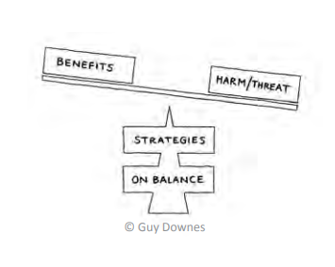
View the decision-making tool animation (3.5mins) www.insightexchange.net/my-safety-kit

Page break
I have my own sense of what is important right now and in the long term.

I have an idea about what I want to do next.

Benefits: What are the benefits of taking this step? If I do this what will be the benefits for me (and my children)
Harm/Threat: What are the potential harms or threats in this step and would that be to my safety and wellbeing (or my children’s)
Strategies: For this particular decision, in what ways could I reduce the potential harm or threat? What are the strategies I am already using or could start using if I make this step?
Balance: On balance, do I need to decide now? Who could support me with these?

Page break
There can be so much going on that it might be hard to remember what happened, when, and to collate my records.
Whether I am making a decision now, later or ever, it might be useful to document my experiences of actual and possible threat or harm, and or changes to my safety and wellbeing as a result of abuse, violence or injury.
This might be useful to me later on when I am:
• making a decision
• needing to provide a record of evidence.
I can use one or more of the apps that are designed to more safely and securely store my records. These may help me be more confident that they won’t be ‘seen’ by others or used against me.

One example is Arc: Arc is an app (or web platform) that supports you to safely collect evidence of family violence. It enables you to note events that make you feel threatened, scared, or unsafe in your relationship. Search for Arc in the Apple or Google Play app stores or visit: www.arc-app.org.au

Page break

There might be some things I can do in the meantime to build on my safety while I think about my options.
I can use one or more of the following links (and many more) to be aware of ideas and ways to build on my safety.
Being social online
• Blogging
• Social Networking
• Online dating
•Online gaming
www.esafety.gov.au/women/being-social
Lifestyle devices
• Know your device
• Using your device
• Shopping and banking
www.esafety.gov.au/women/lifestyle
Taking control online
• Online abuse
• Cyberstalking
• eSafety Planning
• Keeping your children safe online
www.esafety.gov.au/women/take-control Quick exit: The taking control webpage has a quick exit button
Women’s Information and Referral Exchange (WIRE) provides information on browsing anonymously www.org.au/browse-anonymously

Page break

What is available to me and who can support me?

Page break
Responses from others are significant and play a part in my safety.
When someone is controlling and abusing me my situation is complex. No matter how much I try, no matter what ways I resist and respond, the abuser overcomes my resistance. Just because I cannot stop the abuse doesn’t mean I let it happen.
I might want to talk to someone about what is going on or to keep thinking about things first. I might want to think about who I want to talk to, and what I will say.
If or when I do reach out to someone (a person or a service), I don’t have to make any decisions, or all my decisions at once. And no-one should be expecting me to.
I might want to talk with someone about my experience and all the things I am doing already to stay safe. I might want to talk about where I might need support from others.
I might want to talk to someone on the phone, or to talk with someone in person.

About this directory
The list is not intended to be exhaustive. It includes frequently- accessed services that may be a useful starting point for you to explore.
Safe/Quick Exit buttons: Allow you to exit quickly. Browse history is not cleared

Page break
National Contacts
1800-RESPECT
Confidential 24/7 information, counselling and support service, to support people impacted by sexual assault, domestic or family violence and abuse.
P: 1800 737 732 W: www.1800respect.org.au 1800 Respect has a quick exit button.

Full Stop Australia
Sexual, Domestic and Family Violence Helpline Available 24/7 T: 1800 943 539
Rainbow Sexual, Domestic and Family Violence Helpline Available 24/7 T: 1800 497 212
Sexual Abuse and Redress Support Service
T: 1800 211 028
NSW Sexual Violence Helpline T: 1800 424 017
Online counselling available 24/7
W: fullstop.org.au
Full Stop Australia has a quick-exit button.

Kids Helpline
Australia’s free, private and confidential 24/7 phone and online counselling service for young people aged 5 to 25. Anytime. Any Reason.
P: 1800 55 1800 W: www.kidshelpline.com.au Kids Helpline does not have a quick exit button.

For men experiencing Domestic and Family Violence
If you are a man experiencing Domestic and Family Violence you can contact:
• Mensline: 1300 78 99 78 or www.mensline.org.au Mensline does not have a quick exit button.
• 1800-RESPECT: 1800 737 732 or www.1800respect.org.au 1800 Respect has a quick exit button.

Family Violence Law Help
Family Violence Law Help provides information about domestic and family violence and the law in Australia. It includes information about domestic violence protection orders in each state and territory.
W: www.familyviolencelaw.gov.au Family Violence Law Help has a quick exit button.

Ask Izzy
Ask Izzy is a free and anonymous resource for people experiencing family violence. It can help you find the services you need, now and nearby.
W: www.askizzy.org.au Ask Izzy has a quick exit button.

National Debt Helpline
The National Debt Helpline and website is a not-forprofit service that helps people in Australia tackle their debt problems.
P: 1800 007 007 W: www.ndh.org.au National Debt Helpline does not have a quick exit button. It does have a delete chat button.
Page break
ABOUT ECONOMIC ABUSE
Read about Economic Abuse at the Centre for Women’s Economic Safety (CWES) www.cwes.org.au

Fact Sheet (CWES)
What is economic abuse
First steps to economic safety
Next steps to economic safety
Economic abuse and the law
The fact sheets above are available in Arabic, Simplified Chinese, Vietnamese, Korean, Thai, Spanish and English.

Directory of Information and Services
If you are experiencing economic abuse from a current or former partner, or you are still dealing with the consequences of abuse, there are organisations that can support you. The CWES directory provides links to some of these. https://cwes.org.au/directory
The services listed in the directory above can be filtered by state or territory, or by category.

STATE AND TERRITORY SERVICES
Services in each state and territory are included on the following pages including state-based:
• Domestic and family violence Helplines
• Housing support services
• Legal support and information
The list is not intended to be exhaustive. It includes frequently accessed services that may be a useful starting point for you to explore further in your state or territory

Page break
AUSTRALIAN CAPITAL TERRITORY
Domestic Violence Crisis Service (DVCS)
DVCS helps people build lives free from domestic violence and fear. It provides emergency and long term support, advice, domestic violence resources, and services.
P: (02) 6280 0900 (Helpline open 24/7) W: www.dvcs.org.auDVCS has a quick exit button.

One Link
OneLink covers a wide range of support services including services for families and young people, and services for people who are homeless or at risk of homelessness.
P: 1800 176 468 W: www.onelink.org.au One Link does not have a quick exit button.

Women’s Legal Centre ACT
P: From Canberra (02) 6257 4377 | Outside Canberra 1800 634 669 (Mon-Fri 9.30am to midday)
W: www.wlc.org.au Womens’s Legal Centre ACT has a quick exit button

Legal Aid ACT
P: 1300 654 314 W: www.legalaidact.org.au/what-we-do/dv-unit Legal Aid ACT has a quick exit button

QUEENSLAND
DV Connect Womensline
DVConnect’s Womensline is Queensland’s only 24/7 crisis response telephone helpline. It is a service for people in Queensland who want to escape domestic and family violence. It can also connect you to women’s shelters.
P: 1800 811 811 W: www.dvconnect.org DVConnect’s Womensline has a quick exit button.

Homeless Hotline
Homeless Hotline is the Queensland Government’s 24/7 phone information and referral service for people who are experiencing homelessness or are at risk of homelessness, including those experiencing domestic and family violence.
P: 1800 474 753 W: www.qld.gov.au/housing/emergency-temporary-accommodation/homeless-persons-information-qld Homeless Hotline does not have a quick exit button.
Women’s Legal Service Qld
P: 1800 957 957 (Mon-Fri 9.00am to 3.00pm) W: www.wlsq.org.au Women’s Legal Services QLD has a quick exit button.
Legal Aid Qld – Domestic Violence Fact Sheets
P: 1300 65 11 88 W: www.legalaid.qld.gov.au/Find-legal-information Legal Aid QLD has a quick exit button.
Page break
NEW SOUTH WALES
Domestic Violence Line
The Domestic Violence Line is a 24-hour (7 days a week), state-wide telephone crisis counselling and referral service for women and persons who identify as female.
Free call 1800 656 463 | TTY 1800 67 14 42
Translating and Interpreting Services: 13 14 50
W: www.facs.nsw.gov.au/domestic-violence/helpline DV Line has a quick exit button.

Full Stop Australia
NSW Sexual Violence Helpline T: 1800 424 017
Online counselling available 24/7
W: fullstop.org.au
Full Stop Australia has a quick-exit button.

Link2Home Homelessness
Link2home is the NSW information and referral telephone service for people who are homeless or at risk of becoming homeless. It provides callers with information, assessments and referrals to homelessness support and accommodation services.
P: 1800 152 152 (Daily 9am to 10pm) The information and referral telephone service is open 24 hours a day, 7 days a week

Women’s Legal Service NSW

P: 1800 801 501 (limited hours of operation – see website for details)
W: www.wlsnsw.org.au WLSNSW does not have a quick exit button

Legal Aid NSW Fact Sheets and Resources
W: www.legalaid.nsw.gov.au Legal Aid NSW does not have a quick exit button

NORTHERN TERRITORY
Northern Territory Support Services
The Northern Territory Government lists a range of support services that can help if you are experiencing domestic and family violence, depending on your location. NT Govt Support Services does not have a quick exit button.

Shelter Me
Shelter Me provides information to people in the NT seeking accommodation and support services, including crisis, transitional, short term, low cost, and supported accommodation, and other support services.
W: www.shelterme.org.au Shelter Me does not have a quick exit button.

Top End Women’s Legal Service
P: 1800 234 441
W: www.tewls.org.au Top End Women’s Legal Service has a quick exit button.

Northern Territory Legal Aid Commission
P: 1800 019 343
W: www.legalaid.nt.gov.au. NT Legal Aid Commission does not have a quick exit
Page break
SOUTH AUSTRALIA
Women’s Safety Services SA
Women’s Safety Services SA supports women and children who are experiencing and/or escaping domestic and family violence.
The crisis line can help by:
• Facilitating access to safe accommodation
• Providing telephone counselling
• Providing face to face short term counselling
• Providing information about accommodation, police, legal, housing and financial issues
• Supporting you to remain safely at home
P: 1800 800 098
W: www.womenssafetyservices.com.au Women’s Safety Services SA has a quick exit button.

Homelessness Gateway
Eligibility for crisis accommodation for you and your family will depend on your circumstances.
This 24/7 service will assess your situation and work with you to find the best option to suit your needs.
P: 1800 003 308
W: www.housing.sa.gov.au/latest-news/homelessness -gateway-available-24_7 Homelessness Gateway does not have a quick exit button.
Women’s Legal Service South Australia
P: 08 8221 5553
W: www.wlssa.org.au WLSSA does not have a quick exit button.

Legal Services Commission of South Australia
P: 1300 366 424
W: www.lsc.sa.gov.au LSC of SA has a quick exit button.
TASMANIA
Family Violence Counselling and Support Service
The Department of Health and Human Service Family Violence Counselling and Support Service offers professional and specialised services to assist people affected by family violence.
Services include:
• Information, counselling & support
• Information and support to family and friends
• Arranging assistance from police
• Assisting in organising a safe place to stay
• Referrals to Legal Aid and/or Court Support
• Act as an advocate in accessing assistance
P: 1800 608 122 (9am to midnight weekdays and 4pm to midnight weekends and public holidays)
W: www.communities.tas.gov.au/children/family_violence_counselling_and_support_services
Family Violence Counselling and Support Service does not have a safe exit button.

Housing Connect
Housing Connect is the first point of contact for people in housing stress, experiencing homelessness or at risk of homelessness in Tasmania.
P: 1800 800 588
W: www.communities.tas.gov.au/housing/housing-connect Housing Connect does not have a safe exit button.

Women’s Legal Service Tasmania
Confidential Legal Advice and Useful Women’s Resources
P: Free advice line 1800 682 468
W: www.womenslegaltas.org.au. WLS Tasmania has a quick exit button.

Legal Aid Commission of Tasmania
W: www.legalaid.tas.gov.au. P: 1300 366 611
W: www.legalaid.tas.gov.au. Legal Aid Commission of Tasmania does not have a quick exit button.

Page break

WESTERN AUSTRALIA
Women’s Domestic Violence Helpline
This 24/7 service provides support and counselling for women experiencing family and domestic violence in WA. This includes phone counselling, information and advice, referral to local advocacy and support services, liaison with police if necessary and support in escaping situations of family and domestic violence. The service can refer women to safe accommodation if required.
P: Free call 1800 007 339
W: www.dcp.wa.gov.au/CrisisAndEmergency/Pages/Women%27s-Domestic-Violence-Helpline.aspx
Women’s Domestic Violence Helpline does not have a quick exit button.

Entrypoint Perth
Entrypoint Perth is a free assessment and referral service assisting people who are homeless or at risk of homelessness in Western Australia to access accommodation and support options, including people experiencing domestic and family violence.
P: 1800 124 684 Monday – Friday 9:00am – 7:00pm Saturday: 9:00am – 5:00pm Not open Sundays or public holidays.
W: www.entrypointperth.com.au Entrypoint Perth does not have a quick exit button.

Women’s Legal Service Western Australia
P: (08) 9272 8800 or 1800 625 122 (country callers). Mon-Fri 9.30am – 3.30pm
W: www.wlswa.org.au. WLSA has a quick exit button.

Legal Aid WA
P: 1300 650 579 Infoline or Info chat open 9:00 am to 4:00 pm, Monday - Friday
W: www.legalaid.wa.gov.au. Legal Aid WA has a quick exit button

VICTORIA

Safe Steps Family Violence Response Centre
Safe Steps provide specialist support services for anyone in Victoria who is experiencing or afraid of family violence. Safe Steps provides 24/7 telephone crisis line, safety planning and information for family and friends.
P: 1800 015 188 available 24/7 (or email available 24/7)
Webchat: Available Mon-Fri, 9ammidnight.
W: www.safesteps.org.au. Safe Steps Family Violence Response Centre has a quick exit button

Women’s Information and Referral Exchange
Free support, referral and information for all Victorian women, nonbinary and gender-diverse people. Any woman. Any issue.
Live Web Chat: www.wire.org.au/chat-with-wire
P: 1300 134 130
W: www.wire.org.au. Wire has a quick exit button.

Women’s Housing Limited (WHL)
WHL is a state-wide not for profit organisation that provides low costs housing to women at risk of homelessness.
P:(03) 9412 6868 (9:00am – 5:00pm)
W: www.womenshousing.com.au WHL does not have a quick exit button.

Women’s Legal Service Victoria
P: Melbourne: (03) 8622 0600 Regional: 1800 133 302
W: www.womenslegal.org.au Women’s Legal Service Victoria has a safe exit button.

Victoria Legal Aid
P: 1300 792 387 from 8 am to 6 pm weekdays for free information and help about the law. You can also speak to Legal Aid Victoria in your language.
W: www.legalaid.vic.gov.au

Page break

Insight Exchange
Insight Exchange centres on the expertise of people with lived experience of domestic and family violence and gives voice to these experiences.
Insight Exchange is designed to inform and strengthen social, service and systemic responses to domestic and family violence.
www.insightexchange.net
Launched in November 2017, Insight Exchange was designed by Domestic Violence Service Management (DVSM), in collaboration with Dr Linda Coates and Dr Allan Wade from Centre for Response-Based Practice, Canada.
Insight Exchange has been established, developed and is governed by Domestic Violence Service Management (DVSM) a registered charity (ABN 26 165 400 635).
Insight Exchange has been sustained through the generous donations of individuals and a silent donor for the benefit of many.
Copyright and using this resource: The information contained within this resource is for general information purposes only. Insight Exchange assumes no responsibility for how the information in this resource is used.
Read more about Using Insight Exchange www.insightexchange.net/guide-using

EXPLORE INSIGHT EXCHANGE RESOURCES
• What is domestic and family violence?
• My Dignity – My body is mine
• Follow My Lead
• Voice of Insight
Insight Exchange website has a safe exit button.
Scan the QR code to open Insight Exchange.
Privacy: This is a static QR code to eliminate any collection of your data when scanning.
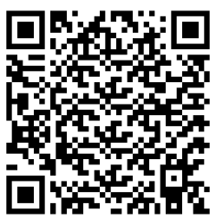

Page break
What is domestic and family violence?
Domestic and Family violence refers to behaviour that occurs in; a current or former intimate partner relationship, a domestic or family relationship, or in an extended family or kinship group.
It can be perpetrated by a partner, spouse, family member, carer, housemate, boyfriend or girlfriend.
Domestic and family violence is behaviour in one of these relationships which is threatening, abusive, violent, coercive or controlling; causing a person to live in fear and to be made to do things against their will. Domestic, family and sexualised violence can happen to anyone. It can take many forms.
Some behaviours that may represent domestic and family violence include…
- Emotional or psychological abuse
- Physical violence
- Sexualised violence
- Reproductive coercion or abuse
- Economic abuse
- Stalking and intimidation
- Technology facilitated abuse
- Spiritual or religious abuse
- Systems abuse
Read more by downloading the fact sheet:
What is domestic and Family Violence? (PDF) hosted on www.insightexchange.net/what-is-dfv Insight Exchange website has a safety button
View the short Insight Exchange animation
‘What is DFV?’ (4mins) hosted on www.insightexchange.net/what-is-dfv/

Page break

Are you looking for information, insights, or support about sexualised violence and abuse?
My Dignity – My body is mine
My Dignity is an information and reflection resource about sexualised violence. My Dignity is for anyone who may be experiencing, or has experienced, sexualised violence and for anyone who may be responding.
Wherever it is difficult to tell someone about domestic and family violence, it may be even more difficult to tell someone about sexualised violence. The intent of My Dignity is to provide information, support reflection, share lived experience insight from others, and signpost to contacts and supports
Read more about My Dignity
www.insightexchange.net/my-dignity/ Insight Exchange website has a safe exit button.
Page break
Are you wanting to be more prepared to respond effectively if someone shares with you their experience of domestic, family or sexualised violence?
Follow My Lead
Follow My Lead is an awareness raising resource that speaks from the voice of people with lived experience of domestic and family violence, who need the professionals and their social networks to be more prepared to respond effectively; more prepared to respond in ways that uphold dignity and build on safety.
Read more about: Follow My Lead
www.insightexchange.net/follow-my-lead/ Insight Exchange website has a safe exit button.

Page break
Are you wanting to read more lived experience insights?
Voices of Insight Collection
The Voices of Insight Collection is a series of original artworks inspired by the Insight Exchange Voices of Insight narratives. The initiative is designed to illuminate visual metaphors and symbols used by Insight Exchange participants as part of how they describe their lived experiences of domestic and family violence to inform social, service and systemic responses. Each of these artworks was developed by collaborating Artist Louise Whelan and is informed by the participants who shared their voices of insight.
After opening the collection, click on a specific image to open the associated lived experience narrative.
Read more about the Arts Lab
www.insightexchange.net/insight/arts-lab-collection/ Insight Exchange website has a safe exit button.

Page break
Free electronic copies of My Safety Kit and short My Safety Kit animations are available on www.insightexchange.net/my-safety-kit
We welcome feedback to improve future editions. Use our Contact Us page.
Insight Exchange would like to thank all contributors, critical friends and communities, who have engaged directly or indirectly with this My Safety Kit resource. We would like to thank Dr Linda Coates and Dr Allan Wade and their colleagues at the Centre for Response-Based Practice, Canada for their visionary and pioneering work on social responses, resistance, language, and the upholding of dignity.
Most significantly, our thanks go to all people with lived experience of domestic and family violence who have generously shared their insights for the benefit of others.
INSIGHT EXCHANGE
www.insightexchange.net

