Follow My Lead
This resource contains descriptions of domestic and family violence.
This resource speaks from the voices of people with lived experience of Domestic and Family Violence who need the professionals and their social networks to be more prepared to respond effectively.
More prepared to respond in ways that uphold dignity and build on safety.
Page break
Your response can be of immense help.
How you respond to me when I share with you, and in the time that follows, matters significantly to me.
I might tell you parts of my experience to test out how safe I am with you and to explore how you react or retreat.
Page break
I’ll be looking to see;
- what you think of what I have shared
- that you believe me
- what you think of me and if/how that changes now that you know more about me
- whether you give more weight to what the person abusing me says than what I say
- whether the person abusing me will be able to influence your thinking and make you think differently about me
and what this means next.
Page break
Are you prepared to respond safely if I share with you?
Page break
Being safe is no simple or single decision, or task.
A good first step is to learn more about my world and how the violence harms my safety and wellbeing.

Page break
Domestic and Family Violence is an injustice and is an offence to my dignity, compromising my safety and undermining my wellbeing… and the dignity and wellbeing of the people I care for and who care for me.
Page break
How you and I view things is personal and unique and can change over time.
I would like you to understand that I know my world best; what it has been, what it is now and what it might become.
I know you want to help but if you oversimplify my world so that you can feel you understand, you lose sight of my challenges and my capacities.
Read on to watch my world build.
This is a map of my world: it’s complex.
Page break
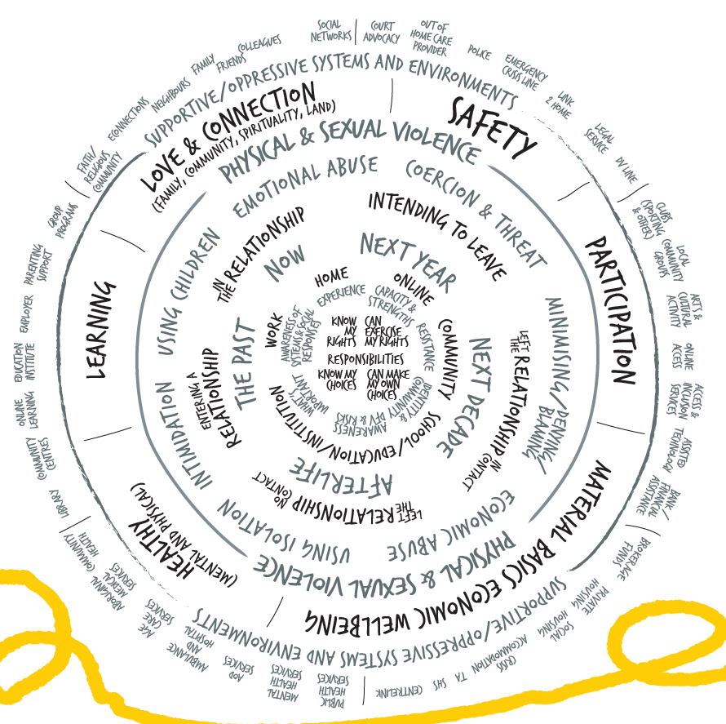

Page break
I am a unique person with unique experiences.
I have rights and responsibilities. I respond to events and exercise choice.
But violence and coercive control limit my options.
Page break
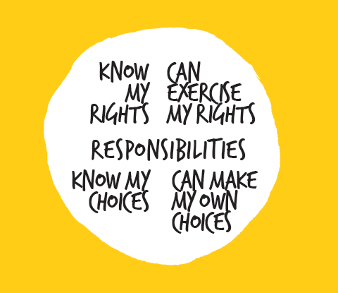
Page break
I have my own sense of what is important right now and in the long term.
I identify with and belong to many communities and networks.
These are the contexts in which I understand and respond to Domestic and Family Violence.
I respond to, and resist, the violence, discrimination and oppression in my own way despite danger and unpredictability.
I am always aware of the actual and possible responses of others, from professionals to my friends and family members.
These responses inform how, or if, I reach out to others.
Page break
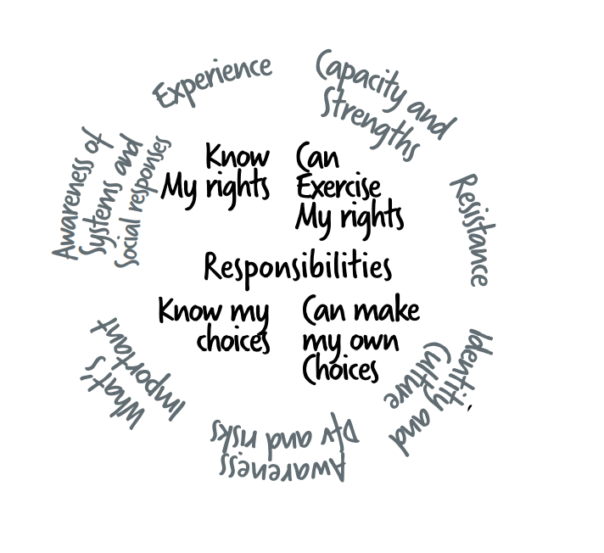
Page break
Where I am (at home, in school, online, on my mobile, at work, in prison, in hospital, in detention, in the community) changes the risks I face and the responses I can expect to receive.
I anticipate and respond to threats and risks wherever I go, with whoever I meet and whatever I do.
Page break
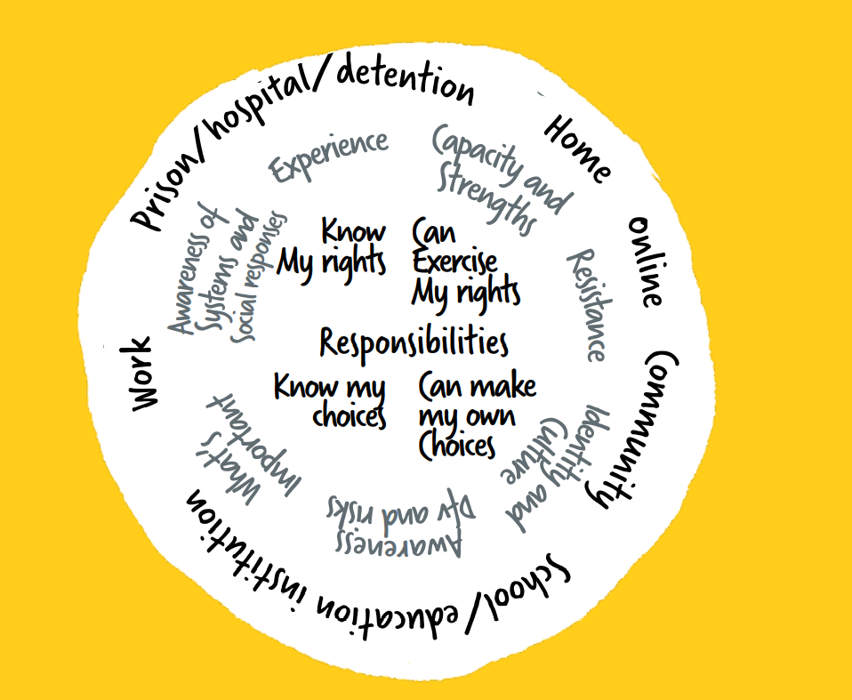
Page break
The risks I face change over time and can change rapidly.
The abuse I have experienced in the past might be similar or different to the current or future threats I face.
The importance I place on the past, the present, the future, and possibly the afterlife, can influence how I see things and make decisions.
Something that makes me safer in the short term might make me less safe in the future.
These facts may be seen or unseen by others, however they are personal and make sense to me.
Page break
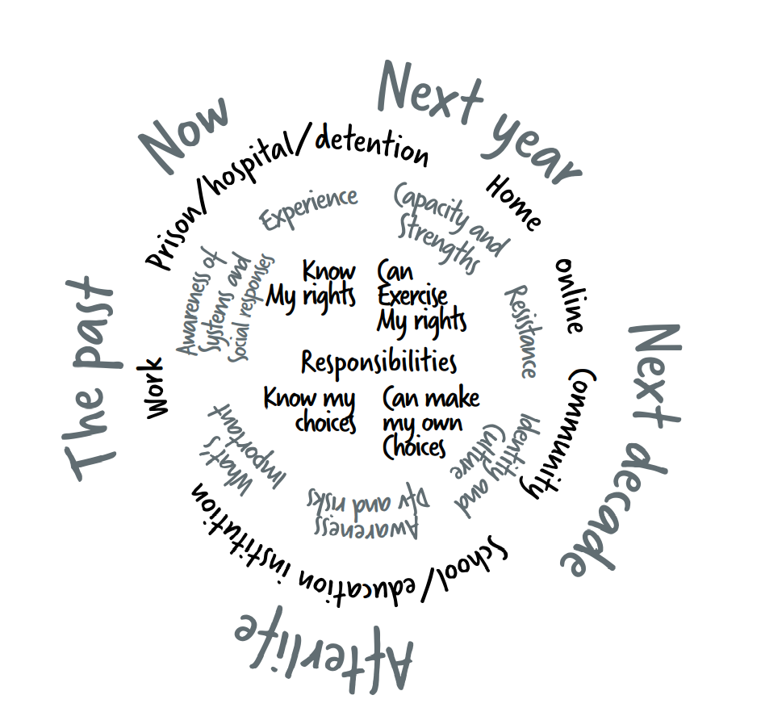
Page break
The status of my relationship matters.
My relationship status with the person abusing me creates different levels of risk, threat and consequences for my dignity and wellbeing.
I might be entering a new relationship, in a relationship with no intention to leave, or planning to leave when I can. I might have escaped but am threatened and forced back into contact with the person abusing me because of the children (or pets, or some other reason). I might have no contact with the person abusing me but know I will (or may) be unsafe if found.
The person abusing me may change the nature of their behaviour rapidly, without warning, significantly changing the realities I face.
I might be in relationships with more than one person who is committing violence against me.
It is my choice whether I am in a relationship and whether I choose to leave it.
Page break
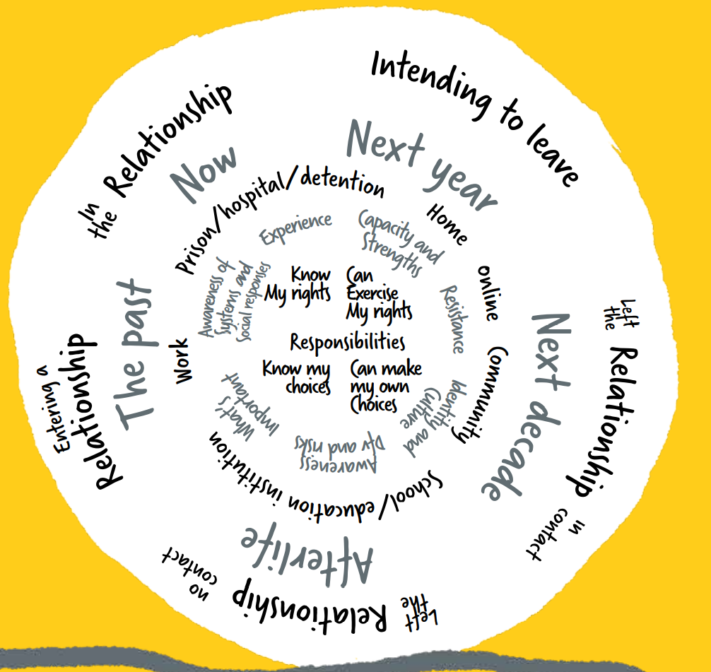
Page break
Just as every person is unique, the violence I experience is unique.
I may be threatened, intimidated or coerced into doing things against my will.
The person committing the abuse may isolate me from those I love and manipulate others against me, and undermine my relationships including my parenting.
They may commit physical, verbal, emotional or sexualised abuse, and they may threaten or abuse my children, friends or family, pets, property, and things that are important to me as a means to control me. They may steal, control or undermine my finances, or my ability to work or be financially independent.
They may try to use my beliefs and spirituality to control and isolate me.
I am experienced in anticipating the patterns and tactics that the person abusing me uses against me and the people I care about. I can see how they adjust their tactics to supress my resistance and responses to their abuse.
The actions of the person who has abused me may be similar to others but are also completely unique and specific to me and those whom I love.
Page break
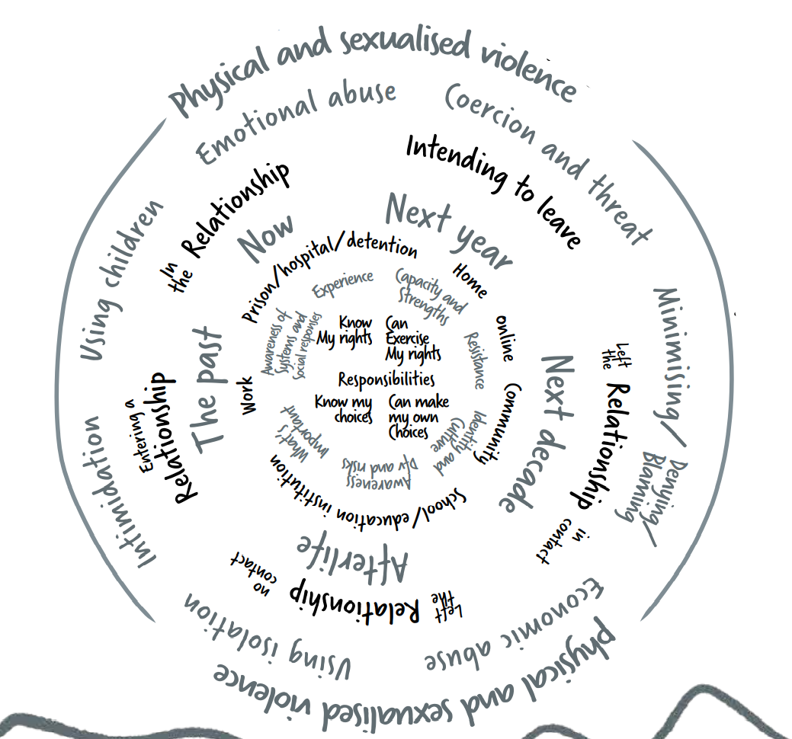
Page break
The violence I experience undermines my wellbeing across many areas of my life.
My responses – the person using violence violates my rights, restricts my choices, and limits my capacity to act and put into force my own decisions.
My safety – my safety is compromised.
Love and connection - my family relationships, friends and connections with community, spiritual connection and connections to land may be under threat.
My learning and growth – because I am forced to deal constantly with abuse, and possibly with negative responses from others, I experience fatigue and isolation. Sometimes I cannot help but ignore or avoid activities that could help me learn and develop as a person because of competing priorities related to violence.
My health – my body and mind suffer from the violence and coercion. I can become physically unwell, fearful, desperate, lonely, sad, and angry.
Although my despair is one form of resistance to the violence, I may be seen as ‘clinically depressed’ or as having another disorder. My feelings are ethical emotional responses to violence.
My material basics and economic wellbeing – the person abusing me tries to suppress my resistance by limiting my access to material and economic basics, such as food, housing, clothing, money and my financial assets. If they can undermine my material and economic wellbeing, they will be more able to use violence.
My participation – my opportunity to participate, have a voice and be involved as a citizen and in the community may be limited.
The violence I experience is an affront to my dignity.
Page break
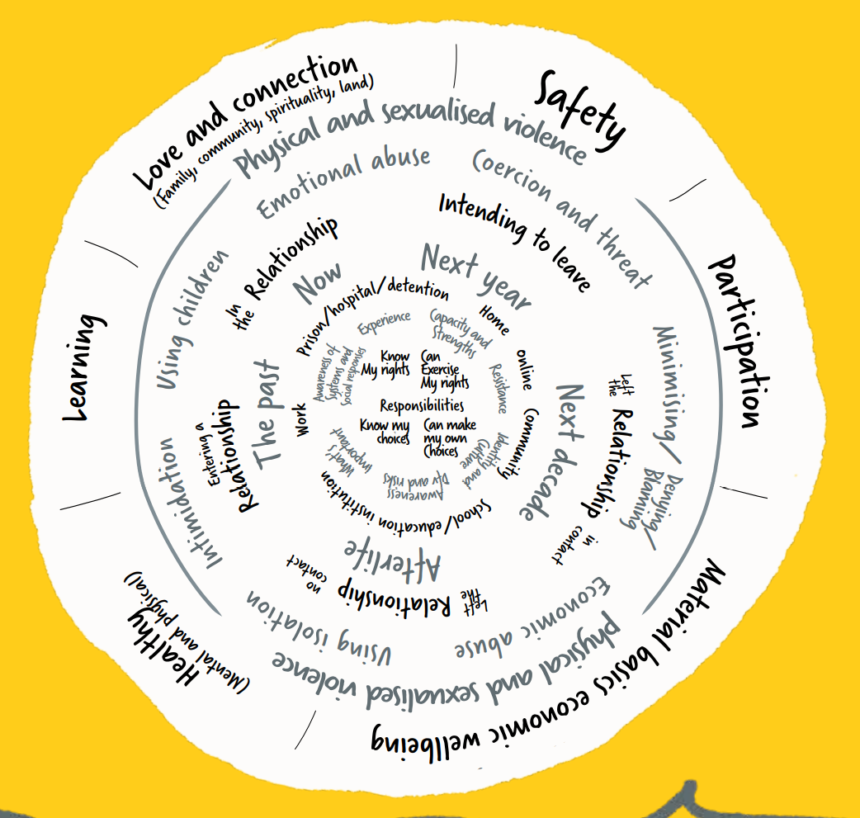
Page break
I may experience supportive, unsupportive or oppressive systems and environments.
My race, gender, sexuality, class, immigration status, ability, age etc. influences the circumstances of my life and the discrimination and oppression I may experience.
When I face multiple forms of discrimination, the person abusing me is empowered to use greater levels of violence and I am isolated from formal and informal support systems.
I may receive both positive and negative social responses from others.
The quality of the social responses I have received influences ‘if’ and ’how’ I engage with social networks and services.
The decisions I make and if/how I take steps is influenced by my context, situation and the coercive control I am experiencing.
Despite this complexity, and even when under immense pressure, I also consider how my decisions to act or not act, may impact the experiences of people and communities I care about.
K Crenshaw (1991) mapping the margins: intersectionality, identity politics, and violence against women of color.
Page break

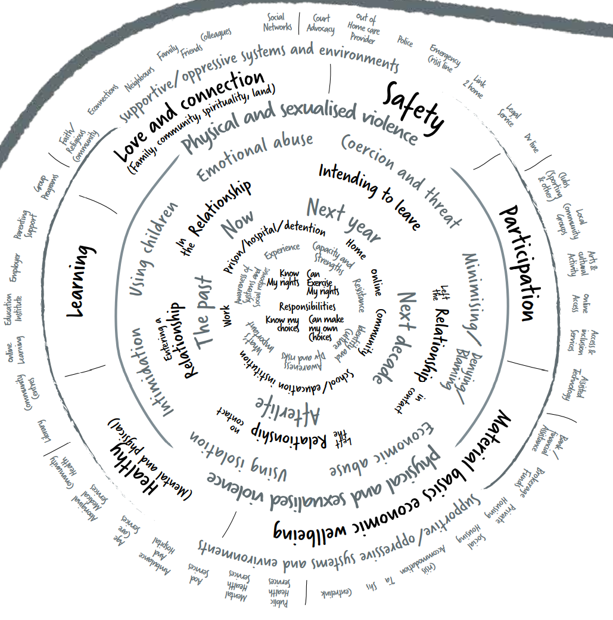
Page break
I resist and respond to the violence, discrimination and oppression I experience.
I do this in visible and invisible ways that might not seem obvious or directly related to what is going on, but this resistance and response to violence is important to me, and is part of upholding my dignity.
The person abusing me knows that I do not like the violence and anticipates that I will resist. Consequently, I must hide my resistance, sometimes completely, and find a safe place in the privacy of my mind.
Page break
How ready are you to respond if I do share with you?
One step to becoming more ready to respond, is to understand what your response might mean to me - how your response can help or how it could harm.
Page break
Please recognise that I am already active in resisting the violence, building safety for myself and others, and managing risk. I am constantly...
- Self-assessing my safety and watching for changes in risk, and forecasting risk.
- Building my safety awareness through information and experience.
- Inventing and implementing ways (tactics/strategies) to keep myself and the people I care about safe.
Page break
Please remember, there may be much more going on than I care to say - until I know you’re safe to share with.
If you try to make decisions for me and tell me what to do, I might feel more unsafe than before I shared with you.
I may not know what I want you to do, I may want you to do nothing, I may want you to do something. I may want your quiet support alongside me, or I may want you to do something proactive, or a mix of these things.
Listen to me and follow my lead.
Let me decide what’s needed and what’s next.
Let me lead the pace and the precision of any steps.
Let me lead.
All of this may take time.
Page break
INSIGHT EXCHANGE
Insight Exchange centres on the expertise of people with lived experience of domestic and family violence and gives voice to these experiences
Insight Exchange is designed to inform and strengthen social, service and systemic responses to domestic and family violence.
www.insightexchange.net
Launched in November 2017, Insight Exchange was designed by Domestic Violence Service Management (DVSM), in collaboration with Dr Linda Coates and Dr Allan Wade from Centre for Response-Based Practice, Canada.
Insight Exchange has been established, developed and is governed by Domestic Violence Service Management (DVSM) a registered charity (ABN 26 165 400 635)
Insight Exchange has been sustained through the generous donations of individuals and a silent donor for the benefits of many.
Copyright and using this resource: The information contained within this resource is for general information purposes only. Insight Exchange assumes no responsibility for how the information in this resource is used. Read more about Using Insight Exchange www.insightexchange.net/guide-using
Insight exchange is for all people. Insight Exchange respects the diversity of all sexualities and gender identities, including but not limited to; Lesbian, Gay Bisexual, Transgender, Intersex, Queer and A-Sexual + identities as well as Heterosexual and Cisgender identities.

EXPLORE INSIGHT EXCHANGE RESOURCES
www.insightexchange.net
Insight Exchange website has a safe exit button.
Scan the QR code to open Insight Exchange.
Privacy: This is a static QR code to eliminate any collection of your data when scanning

Page break
What is domestic and family violence?
Domestic and Family violence refers to behaviour that occurs in; a current or former intimate partner relationship, a domestic or family relationship, or in an extended family or kinship group.
It can be perpetrated by a partner, spouse, family member, carer, housemate, boyfriend or girlfriend.
Domestic and family violence is behaviour in one of these relationships which is threatening, abusive, violent, coercive or controlling; causing a person to live in fear and to be made to do things against their will. Domestic, family and sexualised violence can happen to anyone. It can take many forms.
Some behaviours that may represent domestic and family violence include…
- Emotional or psychological abuse
- Physical violence
- Sexualised violence
- Reproductive coercion or abuse
- Economic abuse
- Stalking and intimidation
- Technology facilitated abuse
- Spiritual or religious abuse
- Systems abuse
Read more by downloading the fact sheet:
What is domestic and Family Violence? (PDF) hosted on www.insightexchange.net/what-is-dfv Insight Exchange website has a safety button
View the short Insight Exchange animation
‘What is DFV?’ (4mins) hosted on www.insightexchange.net/what-is-dfv/

Page break
Are you feeling, uneasy, worried, unsafe, exhausted, fearful or confused about what’s going on in your relationship, and what might happen next?
My Safety Kit
My Safety Kit is a reflection resource that speaks in the voice of the reader who may be reflecting on their own relationship and (possible) experiences of domestic and family violence.
The resource may also have benefits for people who are supporting friends and family who are (or might be) experiencing domestic and family violence, and for people who are working as a service responder to people experiencing domestic and family violence
Read more about My Safety Kit
www.insightexchange.net/my-safety-kit Insight Exchange website has a safe exit button
Page break
Are you looking for information, insights, or support about sexualised violence and abuse?
My Dignity – My body is mine
My Dignity is an information and reflection resource about sexualised violence. My Dignity is for anyone who may be experiencing, or has experienced, sexualised violence and for anyone who may be responding.
Wherever it is difficult to tell someone about domestic and family violence, it may be even more difficult to tell someone about sexualised violence. The intent of My Dignity is to provide information, support reflection, share lived experience insight from others, and signpost to contacts and supports
Read more about My Dignity
www.insightexchange.net/my-dignity/ Insight Exchange website has a safe exit button.

Page break
Are you wanting to read more lived experience insights?
Voices of Insight Collection
The Voices of Insight Collection is a series of original artworks inspired by the Insight Exchange Voices of Insight narratives. The initiative is designed to illuminate visual metaphors and symbols used by Insight Exchange participants as part of how they describe their lived experiences of domestic and family violence to inform social, service and systemic responses. Each of these artworks was developed by collaborating Artist Louise Whelan and is informed by the participants who shared their voices of insight.
After opening the collection, click on a specific image to open the associated lived experience narrative.
Read more about the Arts Lab
www.insightexchange.net/insight/arts-lab-collection/ Insight Exchange website has a safe exit button.

Page break
Insight Exchange acknowledges the Traditional Custodians of the land on which our work and services operate and pay respect to Elders past and present. We extend this respect to all First Nations people across the country and the world. We acknowledge that sovereignty of this land was never ceded. Always was, always will be aboriginal land.
Thanks
Insight Exchange would like to thank all contributors, critical friends and communities, who have engaged directly or indirectly with development of Insight Exchange resources. In particular, we would like to thank Dr Linda Coates and Dr Allan Wade and their colleagues at the Centre for Response-Based Practice, Canada for their visionary and pioneering work on social responses, resistance, language, and the upholding of dignity.
Wade. A. (1997) Small Acts Of Living: Everyday Resistance To Violence And Other Forms Of Oppression. Contemporary Family Therapy 19 (1) March 1997.
Most significantly, our thanks go to all people with lived experience of domestic and family violence who have generously shared their insights for the benefit of others.
Page break

IN AN EMERGENCY
In Australia, call Triple Zero (000) In New Zealand call Triple One (111)
National contacts
1800-RESPECT
Confidential 24/7 information, counselling and support service, to support people impacted by sexual assault, domestic or family violence and abuse.
T: 1800 737 732 W: www.1800respect.org.au 1800 Respect has a quick exit button.

Full Stop Australia
Sexual, Domestic and Family Violence Helpline Available 24/7 T: 1800 943 539
Rainbow Sexual, Domestic and Family Violence Helpline Available 24/7 T: 1800 497 212
Sexual Abuse and Redress Support Service
T: 1800 211 028
NSW Sexual Violence Helpline T: 1800 424 017
Online counselling available 24/7
W: fullstop.org.au
Full Stop Australia has a quick-exit button.

Kids Helpline
Australia’s free, private and confidential 24/7 phone and online counselling service for young people aged 5 to 25. Anytime. Any Reason.
T: 1800 55 1800 W: www.kidshelpline.com.au Kids Helpline does not have a quick exit button.

For men experiencing Domestic and Family Violence
If you are a man experiencing Domestic and Family Violence you can contact:
• Mensline: 1300 78 99 78 or www.mensline.org.au Mensline does not have a quick exit button.
• 1800-RESPECT: 1800 737 732 or www.1800respect.org.au 1800 Respect has a quick exit button.

Page break – Back Cover
View the Follow My Lead animation (4min) are available on www.insightexchange.net/follow-my-lead
Free electronic copies of Follow My Lead and the Follow My Lead animation (4min) are available on www.insightexchange.net/follow-my-lead
We welcome feedback to improve future editions. Use the link to the survey or use our Contact Us page.
Insight Exchange www.insightexchange.net
Page break

